**KWAME NKRUMAH UNIVERSITY OF SCIENCE AND TECHNOLOGY-KUMASI**

**COLLEGE OF ENGINEERING**

**DEPARTMENT OF COMPUTER AND BIOMEDICAL ENGINEERING**

**BIOMEDICAL ENGINEERING**



**FINAL YEAR PROJECT**

*BILIRUBIN LEVEL DETECTION OF NEONATAL JAUNDICE USING COLOUR SENSOR IN PHOTOTHERAPY*

**PROJECT MEMBERS**

SAGOE, PAUL NANA KWAME **(5962416)**

MOHAMMED, TOFFICK **(5961616)**

**PROJECT SUPERVISOR**

Mr. PRINCE ODAME

**JUNE, 2020**

# DECLARATION

This project write-up and presentation is the sole efforts of the members of the project group indicated except where other materials have been used from other authors, which we duly acknowledge in the text.

We hereby certify that this submission is our own work as a requirement for the award of a bachelor’s degree in Biomedical Engineering.

**PROJECT STUDENT**S **SIGNATURE DATE**

SAGOE, NANA KWAME PAUL

**(5962416)**

MOHAMMED, TOFFICK

**(5961616)**

**PROJECT SUPERVISOR**

MR. PRINCE ODAME

**(Lecturer)**

# ABSTRACT

Over the years, blue light phototherapy has been an essential therapeutic mechanism when it comes to the management of neonatal jaundice worldwide. Jaundice is a condition characterized by the yellowish **discoloration** of the skin and conjunctiva of the eye as a consequence of increased levels of serum bilirubin in the blood. The prevalence of this condition in neonates is high compared to adults in general because red blood cells are produced more quickly in babies than adults. Usually, incidences of neonatal jaundice **are** proportionate at 60% in preterm babies and 40% in term babies.

For cases of late diagnosis, neonatal jaundice can lead to permanent damage of brain cells, a condition known as kernicterus. This lethal condition can also cause deafness or hearing loss, cerebral palsy, and profound developmental delay. Fortunately, kernicterus is avoidable through early detection and treatment. High levels of bilirubin can be controlled through phototherapy, a process that involves the use of blue light to break down unconjugated bilirubin to conjugated form that is water soluble and as such can be easily excreted out of the body. For extremely high levels, excess bilirubin must be removed through exchange transfusion.

Generally, laboratory tests and experiments of neonatal blood sample is deployed to monitor the progress of neonatal jaundice treatment during phototherapy. However, this invasive procedure of monitoring the bilirubin concentration in neonates involves the repeated taking of neonatal blood and as such cause’s trauma to infants. Invasive technique also poses the threat of infection possibilities, it also requires the services of experts to perform since the procedure could be tiring and exhaustive and finally the factor of time is also of great concern since usually phototherapy has to be halted for some time until the results from the laboratory experiment is determined.

Having considered the above drawbacks associated with the invasive technique used for bilirubin level detection in jaundiced neonates, we then set the objective of determining bilirubin level in jaundiced neonates using a non-invasive approach. The benefits of this approach include: to minimize complications associated with the taking of blood samples from neonates (e.g. trauma to neonates and also inconveniency on the part of health practitioners as a result of difficulty in drawing blood from neonates). Also, the non-invasive approach enhances jaundice diagnostic time since it cuts off all lab procedures, and lastly the approach prevents the occurrence of infection and wrong diagnosis during the taking of blood samples. The goal therefore of this project is to build a portable device which is less costly and can achieve the same functionality as the non-invasive approach with the above advantages. The device is meant for the determining of bilirubin level and also to ascertain the state of jaundice with the help of a color sensor integrated with an Arduino board and a display unit such as LCD.

# DEDICATION

We dedicate this work to our family and loved ones.

# ACKNOWLEDGEMENT

As our elders say, when you start everything with God all things are possible. It is always through His Grace, Mercy and blessings that we were able to undertake this project and complete this piece of work.

Much respect to our lecturer and supervisor, Mr. Prince Odame, for his support, guidance and being a good influence throughout our time in KNUST and this project work.

Our sincere appreciation also goes to Dr. Mrs Adoma Odame of Hope Exchange Medical Centre and Dr. Ashura Bakari of Suntreso Government Hospital for their moral support and willingness to see this project reaches the peak we envisioned.

We also do acknowledge the support from our families; both financial and spiritual support, throughout this journey of undertaking this project.

**List of figures**

Figure 1 Baby undergoing phototherapy 13

Figure 2 Graph of Absorption Coefficient(mM cm) against Wavelength (nm) 22

Figure 3 Arduino Uno R3 23

Figure 4 TCS230/TCS3200 23

Figure 5:LIQUID CRYSTAL DISPLAY SCREEN 25

Figure 6:PROTEUS SIMULATION 26

Figure 7:COMPONENTS CONFIGURATION 27

Figure 8:FLOWCHART OF DEVICE SETUP AND OPERATION 28

Figure 9: Infant A 30

Figure 10:Infant F 31

Figure 11:Infant B……………………………………………………………………………………..25

Figure 12:Infant C 31

Figure 13:Infant D……………………………………………………………………………………..26

Figure 14:Infant E 32

Figure 15:Graph of Normalized Blue % Against Assigned Bilirubin Level 33

Figure 16 **Sample 1……………………………………………………………………………………28**

Figure 17 **Sample 2………….** 34

Figure 18 **Sample 3…………..** 29

Figure 19 **Sample 4……** 34

Figure 20 **Sample 5…………** 29

Figure 21 **Sample 6…** 35

**LIST OF TABLES**

Table 1 :Comparison of Results 21

Table 2:TCS230 PIN CONFIGURATION 24

Table 3:OUTPUT FREQUENCY SCALING 24

Table 4:CONTROL PHOTODIODES 24

Table 5:Training skin shades table 32

Table 6**: Decision Table** 33

Table 7: Results Table for preliminary test 36

Table 8:Actual Data Analysis Using Real Life Images and TSB values 37

Table of Contents

DECLARATION 2

ABSTRACT 3

DEDICATION 4

ACKNOWLEDGEMENT 5

CHAPTER ONE 9

INTRODUCTION 9

1.1 Background of Study 9

1.2 Problem Statement 10

1.3 General Objective 10

1.4 Specific Objectives 11

1.5 Significance of Work 11

CHAPTER 2 12

LITERATURE REVIEW 12

2.1 History of Neonatal Jaundice 12

2.2 Types of Neonatal Jaundice 12

2.3 Phototherapy Process 13

2.4 Previous Works 14

CHAPTER 3 22

METHODOLOGY 22

3.1 Materials 23

3.1.1 Description of Main Hardware Components Used 23

3.1.2 Software’s Used 25

3.1.3 Simulation of Device Configuration using Proteus 25

3.1.4 Block Diagram showing Configuration of Components 27

3.2 Device Set-up and Configuration 28

3.3.1 Flowchat Of Device Set-up 28

3.3 Product Design Specifications 29

3.3.1 INTRODUCTION 29

3.3.2 DESCRIPTION OF THE PRODUCT 29

3.3.3 OTHER CONSIDERATIONS 29

3.4 Experimental Design 30

3.4.1 Preliminary Data Analysis 30

3.4.2 Actual Data Analysis 36

Table 8: Actual Data Analysis Using Real Life Images and TSB values 37

3.4.3 VIRTUAL DATA ANALYSIS 37

3.4.4 NEONATES USED FOR VIRTUAL ANALYSIS 39

CHAPTER 4 45

RESULTS AND DISCUSSION 45

4.1 Chapter Summary 45

4.2 Preliminary Testing of Device 45

4.3 Final Testing of Device 46

4.3.1 Test 1 47

4.3.2 Test 2 48

4.3.3 Test 3 49

4.4 DISCUSSIONS 49

4.4.1 INCORPORATION OF THE ABOVE MEASURES WITH OUR DEVICE 51

CHAPTER 5 52

CONCLUSION AND RECOMMENDATION 52

5.1 Chapter Summary 52

5.2 Conclusion 52

5.3 Limitations 52

5.4 Recommendations 53

REFERENCES 54

APENDICES 56

FLOW CHART OF MICRO-CONTROLLER CODE 56

MATLAB CODE FOR IMPLEMENTING IMAGE PROCESSING ON THE NEONATES IMAGES 57

TRAINING DATA RELATING NORMALIZED % OF BLUE AND BILIRUBIN LEVEL 57

TABLE SHOWING THE SUMMARY OF THE VIRTUAL DATA ANALYSIS 58

ARDUINO NANO CODE 59

# CHAPTER ONE

# INTRODUCTION

## 1.1 Background of Study

Jaundice is a condition characterized by the yellowish discoloration of the skin and conjunctiva as a consequence of increased levels of serum bilirubin in the blood. This condition is prevalent in preterm and term babies at proportions of about 60% and 40% respectively. Serum bilirubin arises due to the breakdown of old Red Blood Cells (RBCs), which the body gets rid of by the help the liver. However, unlike adults who have matured liver, the liver of neonates is usually immature and not fully developed within the early weeks of birth and as such makes it inefficient in carrying out the functionality of producing the necessary enzymes required to convert unconjugated bilirubin into conjugated bilirubin (water soluble) for efficient excretion out of the body [1].

There is therefore the accumulation of bilirubin in the blood. This is the main cause of jaundice in neonates. Consequently, the RBCs keep breaking down to form more bilirubin; and the accumulation of the bilirubin results in hyperbilirubinemia (a condition of excess serum bilirubin level), which accounts for the signs of neonatal jaundice. For cases of late diagnosis, neonatal jaundice can lead to permanent damage of brain cells, a condition known as kernicterus. This potentially lethal condition can also cause deafness or hearing loss, cerebral palsy, and profound developmental delay. Jaundice in neonates could also result from ABO incompatibility, red blood cell abnormalities, glucose-6-phosphate dehydrogenase (G6PD) deficiency, clotting intricacies and many more [2].

In recent developments of technology and medical practice, two major attempts have been made to provide remedy to this problem. They are phototherapy and blood exchange transfusion. Neonatal hyperbilirubinemia is usually treated using phototherapy, a process that involves the use of blue light to break down unconjugated bilirubin to conjugated form (water soluble) for easy excretion out of the body in the form of stool or urine. For extremely high levels, excess bilirubin must be removed through exchange transfusion; with exchange transfusion the blood of the neonate is repeatedly withdrawn and then replaced (exchanged) with compatible donor blood which is jaundice free [3]. Also, in rare cases of neonatal jaundice as a result of rhesus or ABO incompatibility of mother and baby’s blood, an Intravenous Immunoglobulin (IVI) transfusion is performed. The neonate is transfused with immunoglobulin, a protein in the blood that lowers the activity of the antibodies from the mother that attack and break the red blood cells (RBC) of the neonate.

The treatment method focused on in this project is the phototherapy approach. With phototherapy, blue light is used to break down unconjugated bilirubin to conjugated form (water soluble) for easy excretion out of the body in the form of stool or urine. However, regardless of how efficient and effective phototherapy is when it comes to treating neonatal jaundice, phototherapy itself doesn’t tell us the extent of the bilirubin degradation or the extent of bilirubin concentration reduction in the blood hence there is the need for bilirubin level reduction to be determined and monitored in the course of phototherapy. Generally, laboratory tests and experiments on neonatal blood sample is deployed to monitor the progress of neonatal jaundice treatment during phototherapy. This is conventionally achieved invasively by the physician or nurse pricking the baby with a syringe to draw blood samples which is followed by a laboratory test popularly referred to as Total Serum Bilirubin (TSB) test [1].

However, this invasive procedure of monitoring the bilirubin concentration in neonates involves the repeated venipuncture or blood taking and as such cause’s trauma to infants. Invasive technique also poses the threat of infection possibilities, it also requires the services of experts to perform since the procedure could be tiring and exhaustive and finally the factor of time is also of great concern since usually phototherapy has to be halted for some time until the results from the laboratory experiment is determined [3].

Moreover, the risk of neonatal infection is high since venipuncture or the blood drawing process requires an open skin means. Also, the blood sample must be carefully enclosed in a light resistive tube, as incident light could shine to interact with the collected blood sample in the tube that is about to be tested; hence can eventually lead to a wrong diagnosis. In an attempt to curb these occurrences, we want to build an electronic device to measure the bilirubin concentration in a non-invasive manner using a color sensor and an Arduino board.

## 1.2 Problem Statement

In clinical phototherapy monitoring, invasive technique of determining bilirubin concentration in jaundiced neonates takes time, causes trauma to neonates, and the procedure is also infection prone. Available bilirubinometers are also costly and other non-invasive techniques usually require internet access to function hence may not be readily reliable.

## 1.3 General Objective

This project focuses on building a portable device to non-invasively determine and monitor bilirubin level reduction in neonates with jaundice undergoing phototherapy.

## 1.4 Specific Objectives

* Enhance jaundice diagnostic time by using image processing technique.
* Estimate the amount of blue component in neonatal skin shades after each section of phototherapy. This gives idea of the yellowish discoloration level of the neonate’s skin.
* Another aim is to determine the factors that influence the accuracy of the results and readings given by the device.

## 1.5 Significance of Work

* This work is useful in healthcare facilities specifically in the NICU for enhancing jaundice diagnosing time.
* Elimination of neonatal trauma caused by repetitive venipuncture or heel pricking.
* Prevent the occurrence of infection that could arise due to repeated venipuncture or heel pricking.
* The device is cost friendly and can function without internet connection aid.

# CHAPTER 2

# LITERATURE REVIEW

## 2.1 History of Neonatal Jaundice

Neonatal jaundice may have first been first described in a Chinese textbook 1000 years ago. Medical thesis, essays, and textbooks from the 18th and 19th centuries contain discussions about the causes and treatment of neonatal jaundice. Several of these texts also describe a lethal course in infants who probably had Rh is immunization. In 1875, Orth first described yellow staining of the brain in pattern later referred to by Schmorl as kernicterus. [11]

Jaundice is the most common condition that requires medical attention and hospital re-admission in newborns (especially babies born preterm). The yellow coloration of the skin and sclera in newborns with jaundice is the result of accumulation of unconjugated bilirubin.[11] A bilirubin level more than 85 µmol/l (5 mg/dL) manifests clinical jaundice in neonates whereas in adults a level of 34 µmol (2 mg/dL) would look jaundiced. In newborns jaundice is detected by blanching by the skin with digital pressure so that it reveals underlying skin and subcutaneous tissue.[13] Statistically jaundice affects about 60% of full-term infants in the first week of their life. Although jaundice may sound scary, in most cases it is simply a sign that your baby is adjusting to the outside uterus. [12]

## 2.2 Types of Neonatal Jaundice

Jaundice in neonates can be mainly grouped as pathological or physiological.

**PATHOLOGICAL JAUNDICE**

This is the most dangerous type of jaundice. It occurs within 24-48 hours after birth and your baby’s bilirubin level usually rises fast. The most likely cause is blood incompatibility between the mother and the neonate (different blood rhesus). Pathological jaundice is the leading cause of brain damage in infants called kernicterus due to the deposition of bile pigments in the brain stems. Neonatal deafness could also arise from pathological jaundice. Prompt medical attention is necessary, and in cases where phototherapy fails, blood transfusions may be required [12].

**PHYSIOLOGICAL JAUNDICE**

This condition usually appears at day 2-5 and lasts about 10-12 days. This is a normal transitional state that affects up to 50% of term babies who have a progressive rise in unconjugated levels. The best treatment for physiologic jaundice is frequent and effective breast feeding – at least 8- 12 or more times in each 24-hour period. Giving water, glucose water, or formula doesn’t help since the lack of laxative effect of colostrum can increase the risk of weaning. Causes of physiological jaundice include: increased red blood cells breakdown, liver immaturity resulting in enzymes insufficiency, decrease plasma- binding capacity, and increase re-absorption of bilirubin from the gut [12].

## 2.3 Phototherapy Process

Phototherapy refers to the use of light to breakdown bilirubin molecules in neonates into water soluble isomers that can be easily excreted out by the neonate. In this method of treatment, the baby’s clothing is removed with the exception of the diaper to cover genitals and buttocks in order to protect the gonads or ovaries from the effects of light rays. There is the need to cover the neonate’s with eye patches or shields to also prevent retinal damage and corneal infection. Neonate’s receive this therapy at periodic intervals in hours so as to allow breast feeding and also account for any sort of dehydration that may have arisen due to the phototherapy. This therapy is usually started when the total serum bilirubin level is greater than five (5) times the birth weight of the baby.

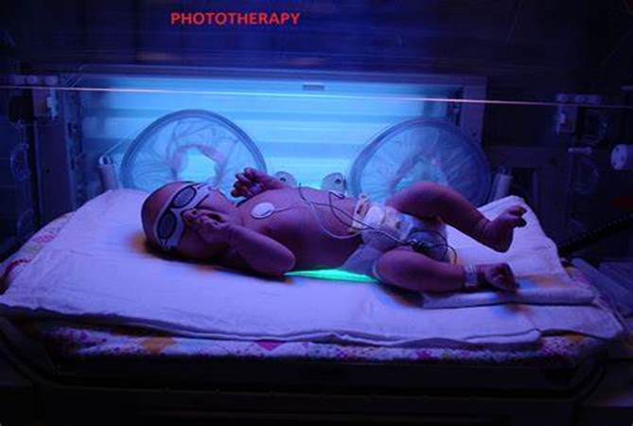

Figure 1 Baby undergoing phototherapy

Blue light in the range of 450-490 nm is most effective for phototherapy because the absorption spectrum of bilirubin lies within this range. Bilirubin therefore absorbs blue light mostly in this range and thus there is minimum reflection of blue light. From this, it is clearly obvious that the more jaundiced the baby, the more the blue light absorbance and the less the reflection of blue light. It follows that, bilirubin concentration and blue light absorbance is linearly related in terms of proportion whereas bilirubin concentration and blue light reflectance is inversely related.

**FACTORS THAT AFFECTS THE DOSE OF PHOTOTHERAPY**

* **Spectral wavelength of the light**: Light in the range of 450-490nm preferred due to its high absorption by bilirubin. Blue light therefore ideal for phototherapy
* **Spectral irradiance to the skin(w/cm):** A measure of how close the phototherapy light source is to the skin of the neonate. Higher spectral irradiance results in rapid decline in bilirubin level, hence a good distance is advised to be maintained between neonate and the lamp or light source.
* **Total Spectral power:** A measure of the average spectral irradiance delivered across the surface area of the baby. Spectral power increases as the amount of skin exposed to phototherapy increases. To make this possible, ensure baby’s clothes are removed to ensure maximum exposure of skin surface area.

## 2.4 Previous Works

**INVASIVE TECHNIQUE MEASUREMENT**

Invasive technique is the common method of assessment of total serum bilirubin (TSB) level. This technique requires blood sample to be withdrawn from the newborn with the use of a needle prick. [4]. When blood samples are taken and various laboratory experiments are performed to determine the exact bilirubin level. As the process is repetitive, it causes trauma to infants and it also requires experts to perform this test. [5] The sampled blood would have to be stored in a dark bag, to avoid light exposure before being sent to lab for analysis and reconsideration.

The DxC800 uses a timed-endpoint **Diazo method** (Jendrassik-Grof) to measure the concentration of total bilirubin in serum or plasma. In the reaction, bilirubin reacts with **diazo** reagent in the presence of caffeine, benzoate, and acetate as accelerators to form azo-bilirubin. [6]

These four bilirubin fractions consist of the unconjugated bilirubin, α-bilirubin; mono-conjugated bilirubin, β-bilirubin; di-conjugated bilirubin, γ- bilirubin; and a fraction irreversibly bound to protein, δ-bilirubin. Nonetheless, this method does not provide any additional information relevant to the clinical setting as well as the high cost of operation. [4] It takes a turnaround time of about 30 mins to be done. These techniques provide a high-level accuracy but may be complicated by infection if poor sterilizing technique, always anemic in repeated blood taking, poor venipuncture technique, pain, and trauma due to repeated sampling that is required in continuous monitoring of the jaundiced infants.

**NON-INVASIVE TECHNIQUE MEASUREMENT**

* **The Bilicam Android app**

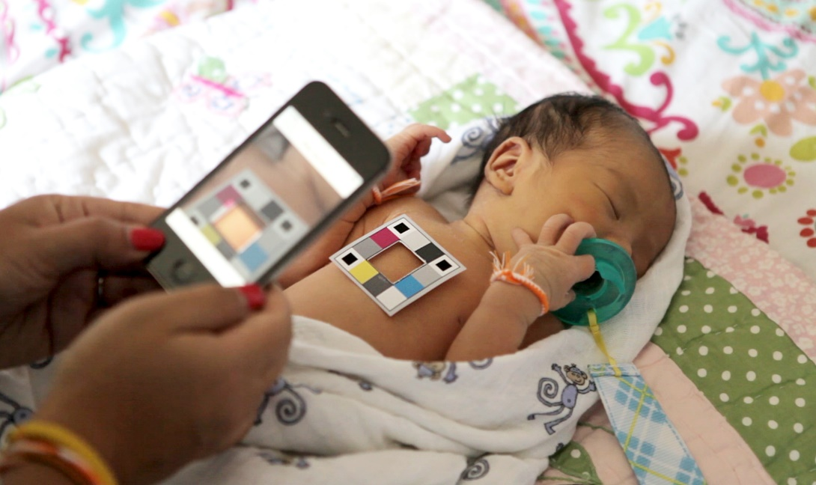

The Bilicam android app is a non-invasive means of determining bilirubin level of neonatal jaundice. This Android based application gives access to your phone’s camera to take images of the neonate’s skin along the color calibration card still in position on the neonate’s skin. The captured image is then sent over a cloud network for further analysis online.

Data on the color values in the images ("features") were extracted by using specialized software developed online. Machine learning and regression analysis techniques were deployed to identify features for inclusion in models to predict the estimated bilirubin level for each newborn. The established correlation between estimated bilirubin levels and TSB levels is used to further analyze the data sent by the phone’s camera to the online cloud. [14]

Bilicam provides accurate estimates of Bilirubin concentration values or TSB values, however its means is subjected to the following drawbacks: Internet connection needed, color calibration card needed, and it is less sensitive to low level bilirubin.

* **Transcutaneous Bilirubinometer**

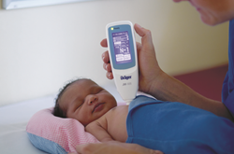 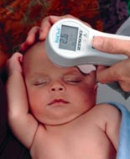

Transcutaneous bilirubinometer (TcB) is a device used to noninvasively estimate serum bilirubin level of neonates, more specifically jaundiced neonates. The American Academy of Pediatrics recommends the use of TcB devices for the screening of jaundice in infants at more than 35 weeks of gestation. Transcutaneous bilirubinometry was introduced into clinical practice in 1980 by Yamanouchi et al. The JM103 was first used in 2003 in Japan [15]

Unlike the Bilicam Android App, the Transcutaneous Bilirubinometer(TCB) is highly effective and accurate in its readings. The TCB operates on the principle of light transmission and reflectance. Light from the TCB is directed to the skin of the neonate, the intensity specific light wavelength returned from the neonate’s subcutaneous tissues (forehead or sternum) is measured and converted to electrical signal by a photocell. The programmed microcontroller finally analyzes the signal produced and then generates a serum bilirubin value.

This device is accurate but costly (3500-4295 USD), also the calibration tip is disposed after each single usage of the device; which leads to an extra cost.

* **Urine test Strip**

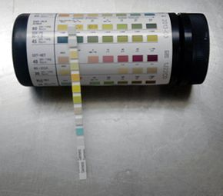

Urine test strips are plastic pieces or waterproofed paper that with a number of absorbent pads soaked with different chemical reagents. Each pad on the urinalysis test strip has a different chemical reagent, hence when a urinalysis test strip is dipped into a urine sample the chemically impregnated pads react with the urine. Dependent on the result of the chemical reaction certain interpretations about the properties of the urine can be interpreted [16].

For bilirubin concentration test, the excreted bilirubin in urine combines with a diazonium salt in an acidic medium to produce an azo dye with colouration that varies from pink to violet. The intensity of the colouration after the reaction of the neonate’s urine with the chemical in the absorbent pad is used to predict the bilirubin level concentration of the neonate.

However for this non-invasive method of estimating bilirubin level concentration, the neonate must pass urine before the test can be conducted, there is a high tendency of false positive errors in the outcome produced from the reactions of the urine and the chemical in the absorbent pad. This is due to the presence of some yellow-orange pigments already in urine (eg. indican)

**DETECTION OF NEONATAL JAUNDICE BY USING AN ANDROID OS-BASED SMARTPHONE APPLICATION**

**1. Background**

Neonatal jaundice resulting from raised blood bilirubin levels is one of the most common clinical conditions that needs medical attention. The major challenge is to differentiate physiologic neonatal jaundice, which is harmless, from pathologic jaundice, which might lead kernicterus and even death. To initiate appropriate management that can both prevent and treat severe neonatal jaundice, screening methods are warranted.

**Methods**

In this study we present an Android OS-based application for detecting neonatal jaundice. To evaluate the design of our smartphone-based system, we conducted a two-center clinical study at Hafez and Shoushtari hospitals, in Shiraz-Iran. A dataset of image samples paired with bilirubin levels of TSB tests was created. 113 neonates were used in the study.

The application was designed to acquire images of newborn babies’ foreheads skin in a standardized manner, also makes use of offline machine learning and regression techniques for analysis. The images are analyzed pixel by pixel and estimates the average R, G, B scores of the images taken from the foreskin and calibration card. The RGB estimates are converted to Hue, saturation, intensity parameters and the application calculates the R, G, B, H, S values using four different formulas namely X1, X2, X3, X4. All these steps are offline and do not require internet connection.

**Results**

All the data gathered from the analysis of each newborn set of images and their matching TSB values were entered into SPSS for statistical analysis. The mean TSB levels in the participants was 6.82 mg/dL with the range of 2.7 mg/dL to 19.3 mg/dL. Four different formulas were used namely X1, X2, X3, X4, each of which has its exclusive Pearson correlation coefficient, sensitivity and specificity to estimate level of image-based bilirubin.

The smartphone-based estimation system had a sensitivity of bilirubin levels had a sensitivity of 68% and specificity of 92.3% for estimating the bilirubin levels of less than 10 mg/dL and sensitivity of 82.1% and specificity of 100% for estimating the bilirubin levels of less than 15 mg/dL.

**Conclusion**

The results suggest that our smartphone-based application can serve as a promising screening tool for infant jaundice. It can serve as a low-cost technology to aid health care professionals and parents to easily screen for neonatal jaundice, in office settings and even during home visits and reduce the mobility of neonatal jaundice. (Padidar P, 2019)

**DETECTING JAUNDICE BY USING DIGITAL IMAGE PROCESSING**

**Introduction**

When high levels of jaundice are present in infants or adults, they are often taken through clinical test like serum bilirubin which can cause pain to the patients. So, in other to avoid additional traumas they proposed to detect jaundice by using non-pain method. Which is simply done by acquiring digital images, in palm soles and forehead. Also analyze RGB attributes and diffuse reflectance spectra as the parameter to characterize patients with either jaundice or not. Support vector machine helps to distinguish between healthy and sick patients.

**Methods**

Digital Image Processing

In this study, the RGB color space was used, which is based on the additive mixture of the three primary colors R, G, B. They form the base vectors of the three-dimensional orthogonal color vector space, where zero-vector represents black. The origin is described as black point.

For an image like $I\left(x,y\right)={(R\left(x,y\right),G\left(x,y\right),B\left(x,y\right))}^{T}$.These values are called tristimulus values.

Support Vector Machine

It is based on the principle of minimization of structural risk in constructing an optimally separating hyper plane that separates different classes of data. A classification task is usually involved with training and testing data which consist of some data instances. Each instance in the training set which contains one target value and several attributes. The goal of SVM is to produce a model which predicts target values of data instances in the testing set which are given only by the attributes.

Mathematically a hyperplane is defined by $w.x+b=0$ in a feature space of a sample data.

**Experimental setup and Results**

A set of 20 Mexican patients, 10 with high level of bilirubin and 10 with low level of bilirubin were used for the study.

*Materials used are*; Spectrometer ocean optics USB 4000 to get the diffuse reflectance spectra, images were acquired with a smart phone camera, camera color 640X480X3 to acquire difference between patients of low-level bilirubin and high-level bilirubin.

Fluorescent lamps were used which luminance of light was controlled at 180 lux inside the room. By one side we measure the level of bilirubin with a bilirubinometer BILITEST from technomedicine to distinguish between high and low level of bilirubin. For other side we measure rms of the RGB, the diffuse reflectance spectra and for reference the level of bilirubin for each patient. Due a best signal of bilirubin, we measure four parts of the body palm, sole, forehead and arm.

**Conclusion**

Support vector machine together with digital image processing seems to be a good technique to distinguish between low and high levels of bilirubin, there was an obtained sensitivity of 71.8 % and a specificity of 78.8 obtained with 20 spectra, 10% with high bilirubin and 10 with low level of bilirubin. As future work would will work with more patients to improve the sensitivity and specificity levels. (J. Castro-Ramos, 2014)

JAUNDICE IN NEWBORN MONITORING USING COLOR DETECTION METHOD

**Introduction**

A bilirubin level of more than 85 umol/l (5 mg/dL) manifests clinical jaundice in neonates whereas in adults a level of 34 umol/l (2 mg/dL) would look icteric. In newborns jaundice is detected by blanching the skin with digital pressure so that it reveals underlying skin and subcutaneous tissue. Studies have shown that trained examiners assessment of levels of jaundice show moderate agreement with icterometer bilirubin measurements.

The goals of this paper are to promote a new first aid of jaundice newborn monitoring. A simple color detection method was employed to study the behavior of the infant.

**Methods**

The long-term goal of this research is the development of a stand-alone automated system that could be used as a supplement in the NICU to provide 24-h/day noninvasive.

**Infant Jaundice Monitoring**

The study relied on images selected from a random database developed by <http://infantmonitoring.com>. This variety of images gives the further experiment more interest in order to find a robust portion to monitor the infant jaundice. Infant jaundice is treated with a special light called phototherapy.

Skin Detection

This is based on $YCrCb$ color space, where the advantages are chroma $(CrCb$) and luminance (Y) information. In $YCrCb$ color space, it is simply to be done by not using one of its channels. The result of Face Detection is first processed by a decision function based on the chroma components $CrCb$ from $YCrCb$ and Hue from HSV by creating a Skin Map.

**Results and Discussion**

In this $YCrCb$ color spaces are used for skin detection.

A comparison between jaundiced and normal baby.

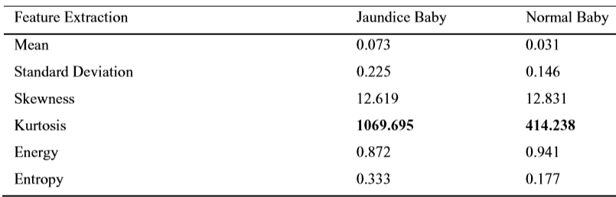

Table 1 :Comparison of Results

Based on the table 1 given, Kurtosis gives the higher value from another feature. This feature can be used to classify in order to distinguish between normal and not normal newborn.

**Conclusion**

With deeper analysis and adding an interpretation module and classifier, the decision about the pose feature extraction such as kurtosis can be made, so the robust image detection can be developed. When the background is similar to skin tone, by adding the morphological information, the facial possibility of the detected part can be estimated. (Mansor, 2012)

# CHAPTER 3

# METHODOLOGY

This chapter focuses on three key aspects of the project. First, on the materials or components (both hardware and software) used, then talks about the device setup and configuration, and lastly the experimental design.

Analysis of RBG components extracted from the images of both jaundiced and non-jaundiced neonates was conducted for a comparative study. The outcome thereof deciphers that blue component in the RBG extracted from the image of the jaundiced neonate is lower than the blue component in the RBG extracted from the non-jaundiced neonate. The project therefore rests on the shoulders of this concept of amount of blue light reflectance to determine the level of bilirubin in the neonate.

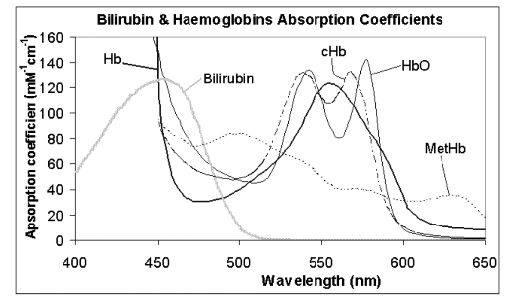

Figure 2 Graph of Absorption Coefficient (mM cm) against Wavelength (nm)

## 3.1 Materials

### 3.1.1 Description of Main Hardware Components Used

There main components used in the project include;

* ARDUINO NANO

This is a microcontroller board based on a removable, dual-inline-package (DIP) ATmega328 AVR microcontroller. It is the smallest type of Arduino but equally does the same work. Written Arduino code can be loaded onto it form an easy to use Arduino IDE. Arduino has a very extensive support community online and everywhere in the world so it’s very easy to start with embedded electronics. [10]

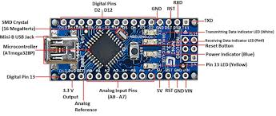

Figure 3 Arduino Nano

* TCS230/TCS3200 (RGB color sensor)

It’s a programable color light-to-frequency converter combines configurable silicon photodiodes and a current-to-frequency converter on a single monolithic CMOS integrated circuit. [8] The light-to-frequency converter consists of an 8x8 array of photodiodes with red, green, blue colored filters (16 photodiodes each) and 16 photodiodes with no filter. The photodiode filters can be selected using S2 and S3 pins.[9]

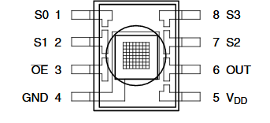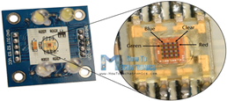

Figure 4 TCS230/TCS3200

**TCS230/TCS3200** **PIN CONFIGURATION**

|  |  |  |
| --- | --- | --- |
| **PIN NAME** | **PIN NUMBER** | **DESCRIPTION** |
| GND | 4 | Power Supply ground. All voltages are referenced to the ground |
| VCC | 5 | Supply voltage |
| OE | 3 | Output Enable for FO(Active low) |
| OUT | 6 | Output frequency (fO) |
| S0 , S1 | 1,2 | Select lines for output frequency scaling |
| S2 , S3 | 7,8 | Select lines for photodiode type |

Table 2:TCS230 PIN CONFIGURATION

**OUTPUT FREQUENCY SCALING**

|  |  |  |  |
| --- | --- | --- | --- |
| **S0** | **S1** | **Max Output Frequency (kHz)** | **% Scale** |
| H | H | 600 | 100% |
| H | L | 120 | 20% |
| L | H | 12 | 2% |
| L | L | Power down | Power down |

Table 3:OUTPUT FREQUENCY SCALING

**CONTROL PHOTODIODES**

|  |  |  |
| --- | --- | --- |
| **S2** | **S3** | **Selected Photodiode** |
| L | L | Red |
| L | H | Blue |
| H | L | Clear (No filter) |
| H | H | Green |

Table 4:CONTROL PHOTODIODES

* **Liquid crystal Display screen**

It’s an electronic display module which uses liquid crystal to produce a visible image. The commonly used module is the 16x2 LCD which is used in circuits and DIY. In this LCD each character is displayed in a 5x7 pixel matrix. [7]

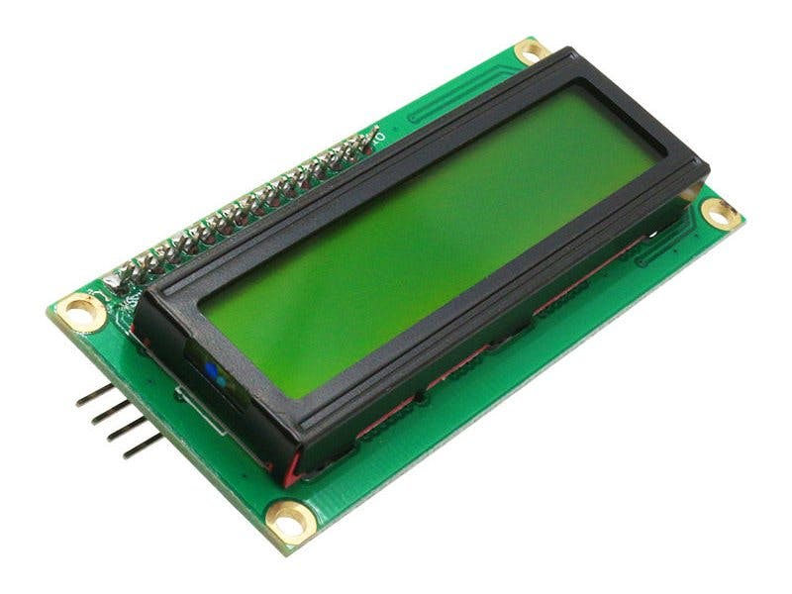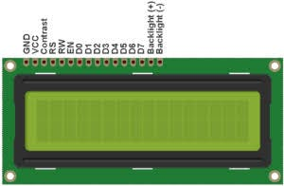

Figure 5:LIQUID CRYSTAL DISPLAY SCREEN

### 3.1.2 Software’s Used

* **MATLAB**: For RGB image processing and graph plotting
* **Proteus**: For schematic capture and simulation of electronic design and device setup.
* **Fritzing**: Electronic Design Automation (EDA) tool for Connecting color sensor to

Arduino.

### 3.1.3 Simulation of Device Configuration using Proteus

Because the Arduino is the motherboard, that means all the other components will be connected to it and the simple computer code will be uploaded onto it.

How the TCS230 and 16x12 LCD was connected to the Arduino

S0 – pin 4 D4 – pin 5

S1 – pin 5 D5 – pin 4

S2 – pin 6 D6 – pin 3

S3 – pin 7 D7 – pin 2

Sensor Out – pin 8 Enable – pin 11

Ground – GND RW – GND

VSS - GND

**DIAGRAM SHOWING DEVICE SIMULATION IN PROTEUS**

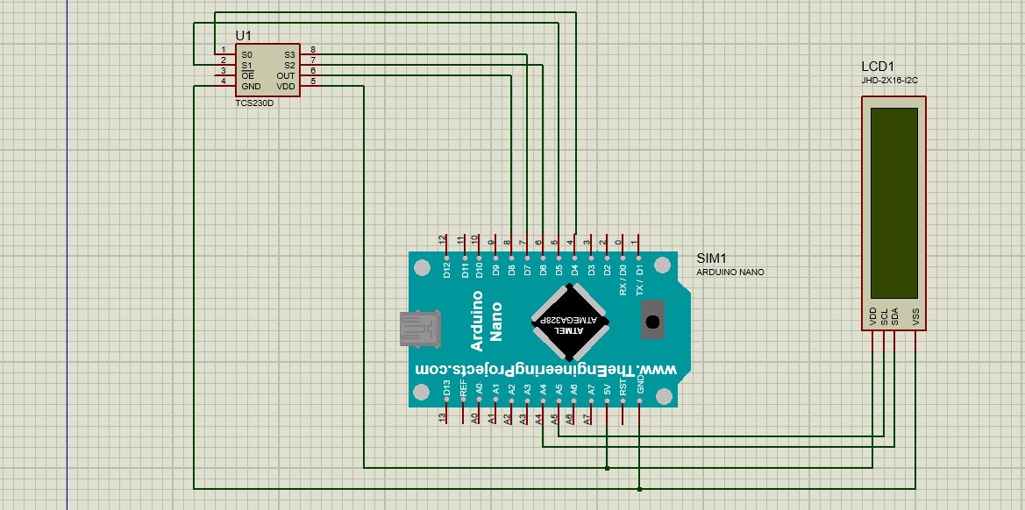

Figure 6: PROTEUS SIMULATION

#### 3.1.3.1 DIAGRAM SHOWING EAGLE FABRICATION FOR PCB DESIGN

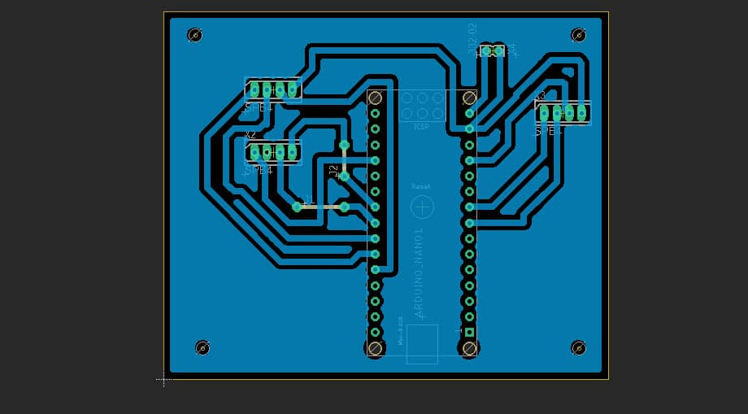

#### 3.1.3.2 3D MODEL OF DEVICE CONNECTION

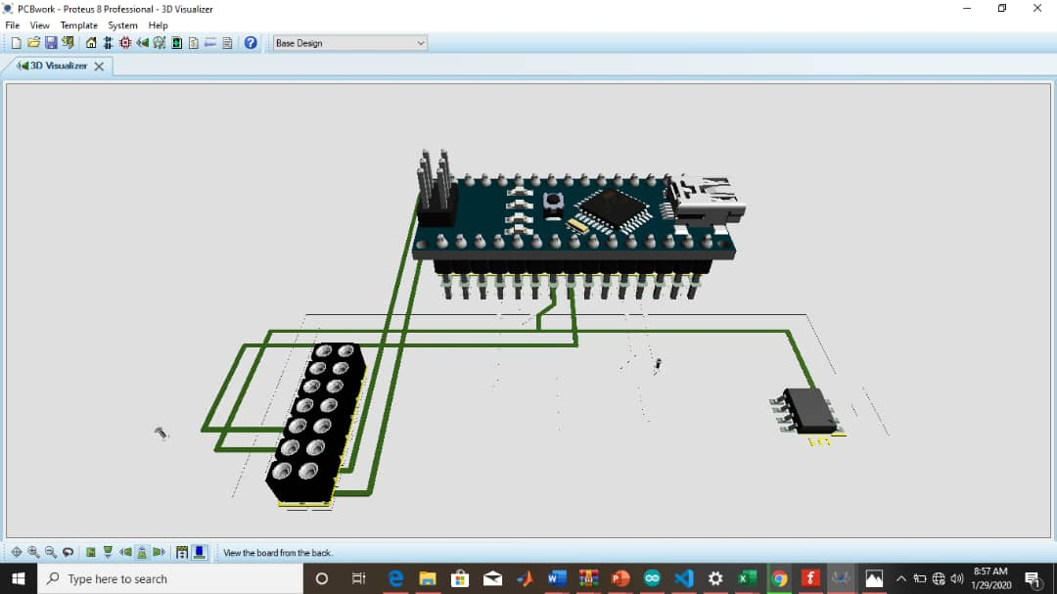

### 3.1.4 Block Diagram showing Configuration of Components

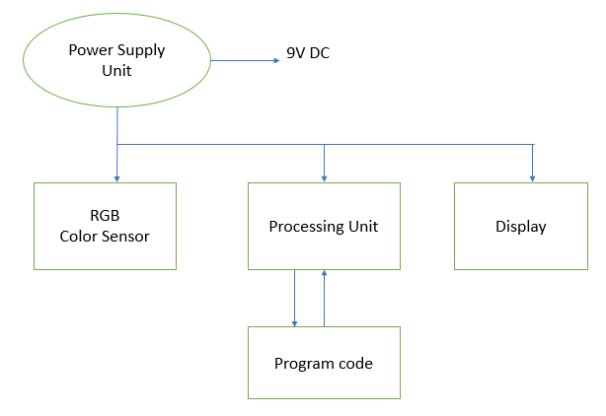 Figure7: COMPONENTS CONFIGURATION

## 3.2 Device Set-up and Configuration

### 3.3.1 Flowchat Of Device Set-up

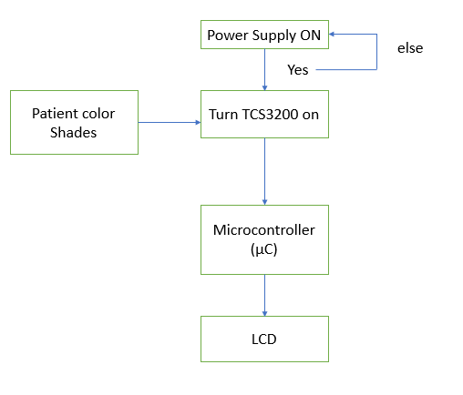

Figure 8:FLOWCHART OF DEVICE SETUP AND OPERATION

The power supply unit provides 9V DC supply to the processing unit. The RGB color sensor TCS 3200 is then used to sense the RGB component of skin shades of the neonate printed on paper. The sensed RGB values of the printed skin shade is then sent into the processing unit, based on Arduino Uno for further decision analysis. This is achieved by the help of the photodetector of the RBG color sensor.

The processing unit maps RGB value to specific values in order to configure the color sensor followed by the calculation and normalization of the percentage of blue taken from the color sensor. Based on predefined equation coded in the system after the MATLAB image processing, the appropriate bilirubin level is determined and thus the state of jaundice is ascertained from a decision table and the results is transferred for display on the display unit (LCD).

## 3.3 Product Design Specifications

### 3.3.1 INTRODUCTION

1. Purpose

The conventional methods of monitoring the bilirubin level of jaundiced neonates during phototherapy is invasive, expensive and sometimes causes pain and trauma to the neonate.

.

1. Features

### 3.3.2 DESCRIPTION OF THE PRODUCT

1. Product Description and Rationale

This project focuses on building a portable device to non-invasively determine and monitor bilirubin level reduction in neonates with jaundice undergoing phototherapy.

1. Environment

The product will be used mainly in the hospital, specifically the Neonatal Intensive care unit (NICU) on jaundiced neonates.

1. User Characteristics

The main uses will be Doctors specialized in the area of pediatrics and the nurses in the unit also be trained on the usage of the device.

1. Size

Minimum size

1. Product life

It can last for an approximate 2 years where the batteries must be changed

1. Casing

Made to fit the shape of the device circuit

### 3.3.3 OTHER CONSIDERATIONS

MARKET

The target market will be rural hospitals that admit lot of jaundice cases regularly.

COST

Minimum cost (GHC 100 – GHC 500)

HAZARD

Product was designed in such a way that it would not cause any harm to the user.

## 3.4 Experimental Design

### 3.4.1 Preliminary Data Analysis

This analysis was performed using 6 neonatal images (both jaundiced and non-jaundiced). Each image was considered as a sample and analyzed using MATLAB 2016 to obtain the corresponding ***R, G and B*** color components. The goal of the image processing was to find the ***R, G and B*** color components of each image and use this information to calculate the normalized percentage of blue color component of each image (sample). The skin color shades of the neonates were also obtained.

Normalized % of Blue = $\frac{Blue}{Red+Green+Blue}*100$ Equation 1:Normalized % of Blue

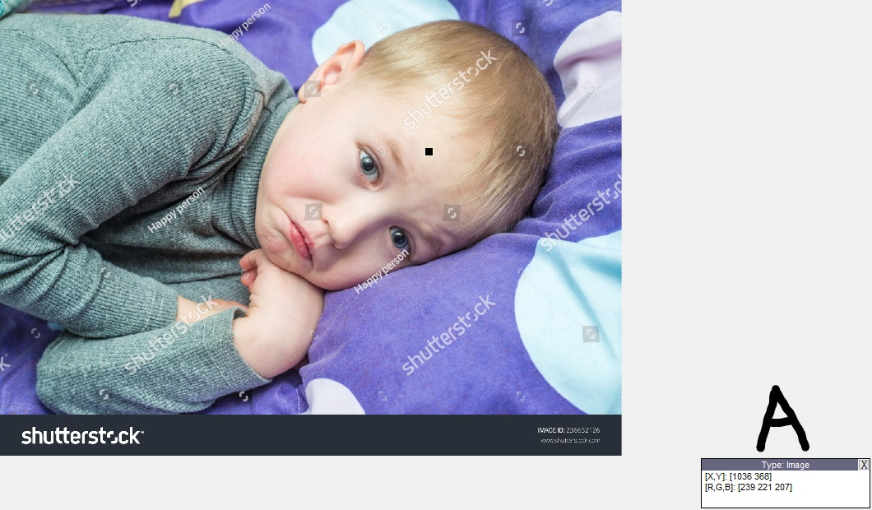

Figure 9: Infant A

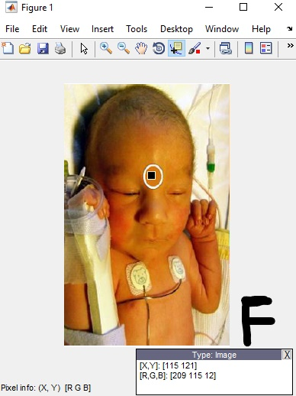

Figure 10:Infant F

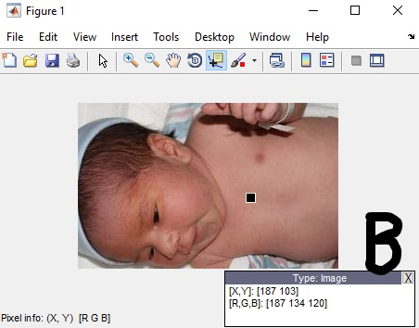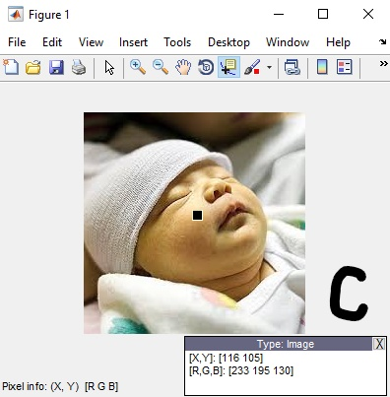

Figure 11:Infant B Figure 12:Infant C

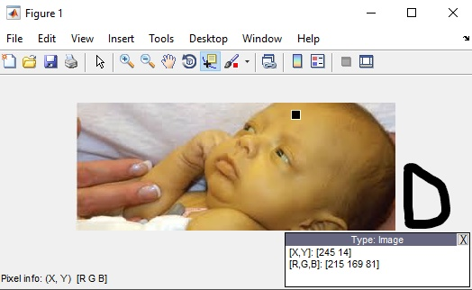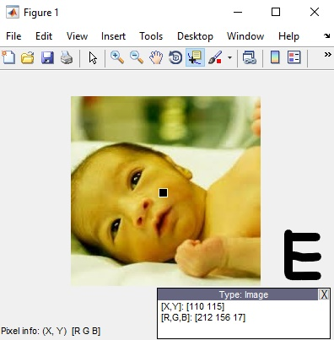

Figure 13:Infant D Figure 14:Infant E

#### 3.4.1.1 TRAINING DATA RELATING NORMALIZED % OF BLUE AND BILIRUBIN LEVEL

|  |  |  |  |
| --- | --- | --- | --- |
| Sample | Shade of Skin | Assigned Bilirubin level (mg/dL) | Normalized % of Blue |
| A |  | 1.5 | 31.30 |
| B |  | 2.5 | 27.21 |
| C |  | 8.5 | 23.30 |
| D |  | 16 | 17.42 |
| E |  | 21 | 4.42 |
| F |  | 23 | 3.57 |

**Table: Training shades table**

Table 5:Training skin shades table

#### 3.4.1.2 Graph of Assigned Bilirubin Level Against Normalized % Of Blue

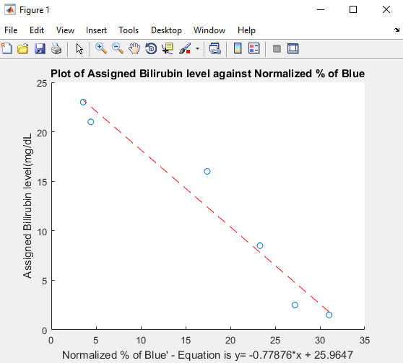

Figure 15:Graph of Normalized Blue % Against Assigned Bilirubin Level

|  |
| --- |
| Equation 2 **Y = - 0.77876* x + 25.9647** |

The above equation is the best fit line equation generated with MATLAB from the data provided by the table. **X** represents normalized blue percentage calculated from each skin shade. Using the above equation, bilirubin level corresponding to any particular shade is calculated. The processing unit therefore will determine the state of jaundice based on the decision table given below.

|  |  |
| --- | --- |
| **Bilirubin Level (mg/dl)** | **Jaundice Condition** |
| Bilirubin level < 4 | Normal |
| 4 < Bilirubin level ≤ 10 | Mild |
| 10 < Bilirubin level ≤ 20 | Severe |
| 20 < Bilirubin level | Critical |

Table 6**: Decision Table**

In order to test the strength of the correlation between the assigned bilirubin level and normalized blue percentage of the established equation, few sample images of both jaundiced and non-jaundiced neonates have been taken and analysed with MATLAB to determine the corresponding **R, G** and **B** components. The shade of skin colour has been extracted and printed on the paper. These images are taken from Google images. These are treated as sample images for testing. Given below are the images used as samples along with the responses which we get after testing.

**NON- JAUNDICED SAMPLES**

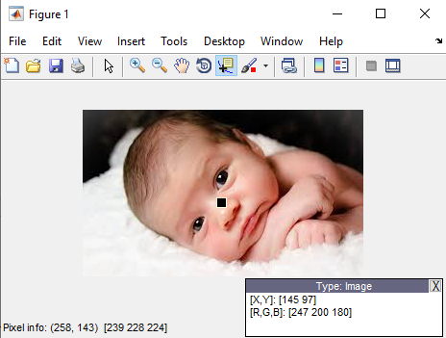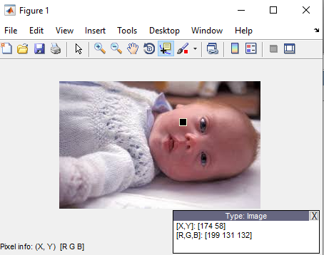

Figure 16 **Sample 1** Figure 17 **Sample 2**

**JAUNDICED SAMPLES**

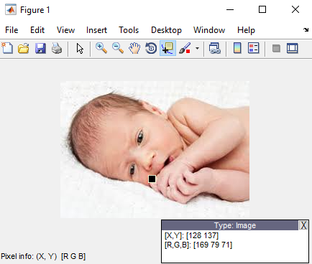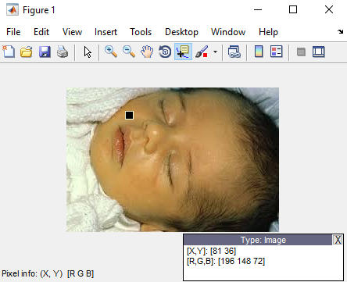

Figure 18 **Sample 3** Figure 19 **Sample 4**

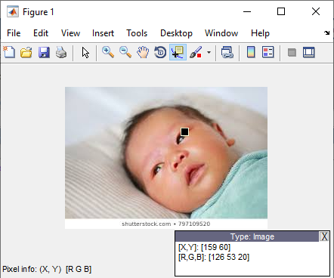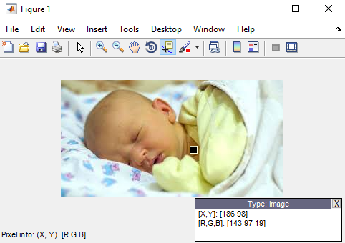

Figure 20 **Sample 5** Figure 21 **Sample 6**

#### 3.4.1.3 RESULTS FOR PRELIMINARY DATA ANALYSIS

**X =** Normalized blue percentage

**Y=** Bilirubin level Calculated

X = $\frac{Blue}{Red+Green+Blue}*100$ (Equation 3)

Y = **- 0.77876* x + 25.9647 (**Equation 4)

Using the above relations, the normalized blue percentage, corresponding bilirubin level concentration, and the state of jaundice is computed for each image sample. The results are displayed in the table below.

|  |  |  |  |
| --- | --- | --- | --- |
| **Sample No.** | **Normalized % of blue**  **(X)** | **Estimated bilirubin level(mg/dl), (Y)** | **Jaundice Condition** |
| 1 | 28.71 | 3.61 | Normal |
| 2 | 28.57 | 3.72 | Normal |
| 3 | 22.26 | 8.63 | Mild |
| 4 | 17.30 | 12.50 | Severe |
| 5 | 10.05 | 18.14 | Severe |
| 6 | 7.34 | 20.25 | Critical |

Table 7: Results Table for preliminary test

#### 3.4.1.4 Discussions on Preliminary Testing

From the above results, it can be clearly deciphered that the established equation is of high accuracy and also the correlation between normalized blue percentage and bilirubin level is very strong. However, regardless of the accuracy and satisfaction obtained from this preliminary data analysis, the preliminary data experimentation was not based on real life data. We wisely assigned bilirubin concentration with the help of our MATLAB image processing tool, rather than using actual bilirubin values from Total Serum Bilirubin (**TSB**) test from the laboratory or hospital.

### 3.4.2 Actual Data Analysis

This describes the process and analysis of how the actual data for this project would have been gathered and utilized in the build-up of this project.

For the actual data analysis of this project, we intended using real life neonates (babies) from the NICU as our subjects for the MATLAB image processing along with laboratory determined bilirubin concentration values of TSB test from the hospital. The values of these parameters are taken at same time right after phototherapy is halted for monitoring, hence the computed parameter values for the various equal times of monitoring the condition is used to establish the relationship between normalized blue percent and actual TSB values.

The Table below summarizes the idea of the information we intended to capture for our actual data analysis.

|  |  |  |  |
| --- | --- | --- | --- |
| **After Time (T) of Phototherapy** | **TSB value (mg/dl)**  **(From Lab test)** | **RGB values**  **(from MATLAB)** | **Calculated Normalized % of Blue** |
| **T0** |  |  |  |
| **T1** |  |  |  |
| **T2** |  |  |  |
| **T3** |  |  |  |
| **T4** |  |  |  |

Table 8: Actual Data Analysis Using Real Life Images and TSB values

However, our intention of getting real life neonates as well as laboratory determined TSB values from the hospital was hindered by the corona virus pandemic. Therefore we resulted to the usage of an online dataset containing neonatal images. These neonatal images were used in place of the real life neonates from the NICU we intended to initially use for our actual data analysis. The corresponding TSB values for these neonatal images were also intelligently determined by the help of the image processing we conducted from MATLAB. Below is the virtual data analysis, which is similitude of how we intended acquiring and processing our data for this project.

### 3.4.3 VIRTUAL DATA ANALYSIS

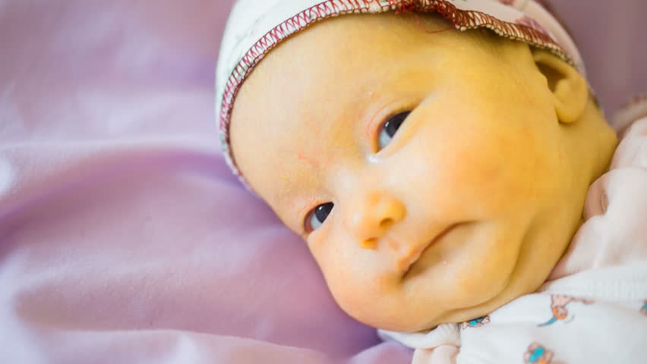 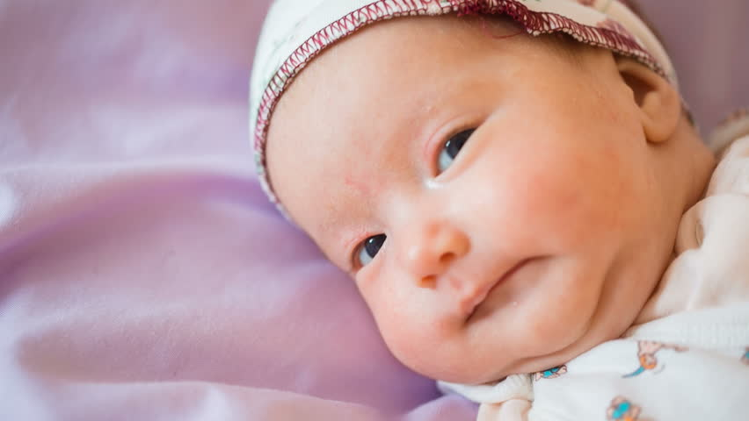

The images above shows the treatment process of a jaundiced neonate undergoing phototherapy. Image A shows the initial treatment while Image B shows a later treatment of the sme neonate. The yellowish countenance of the neonte in Image B is better than in Image A from above which is an indication that phototherapy is effective in improving and treating neonatal jaundice.

#### 3.4.3.1 ANALYSIS FROM MATLAB IMAGE PROCESSING

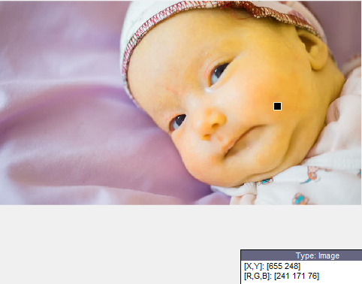 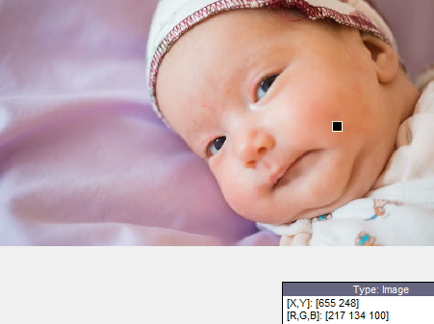

Now with the help of MATLAB, the RGB components of the two images ;( Image A and Image B) were analyzed from the same image pixel perspective; [X, Y: 655,248].

The image processing of the first image shows the initial treatment of the jaundiced neonate with RGB reading as [241, 171, 76].

Also, the second image which depicts a better yellow countenance of the neonate also confirms that there is an improvement of the treatment by phototherapy which is also evident in the corresponding RGB values obtained as [217,134,100] at the same image pixel as Image A.

|  |  |  |  |  |
| --- | --- | --- | --- | --- |
| **After Time (T) of Phototherapy** | **RGB values**  **(from MATLAB)** | **Normalized % of Blue** | **TSB value (mg/dl)**  **(From Lab test)** | **Jaundice State** |
| **T0** | [241, 171, 76] | 15.57% | 13.84 | Severe |
| **T1** | [217,134,100] | 22.17% | 8.70 | Mild |

The same procedure above is deployed to analyze fifteen (15) other neonatal images below. The data from the MATLAB image processing of these images are shown below.

### 3.4.4 NEONATES USED FOR VIRTUAL ANALYSIS

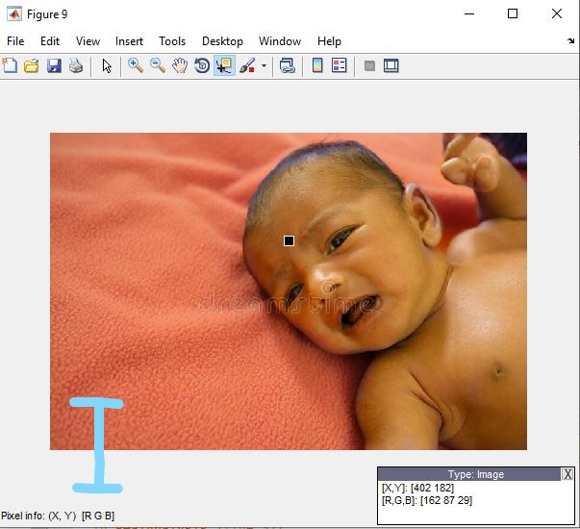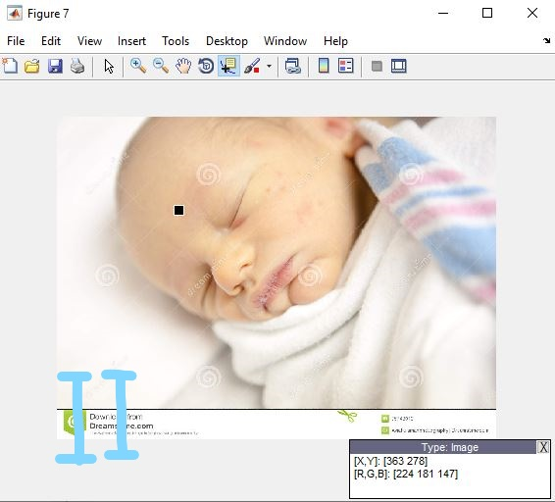

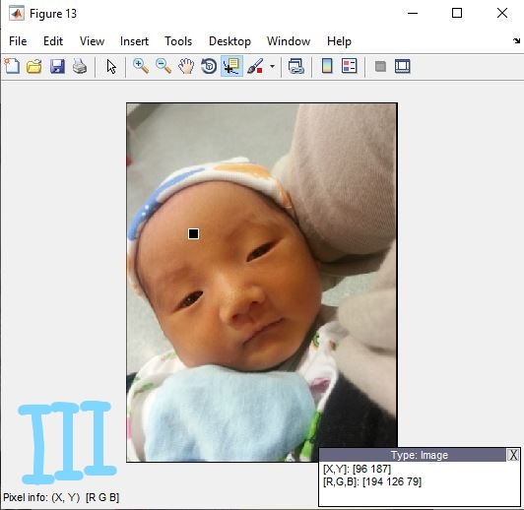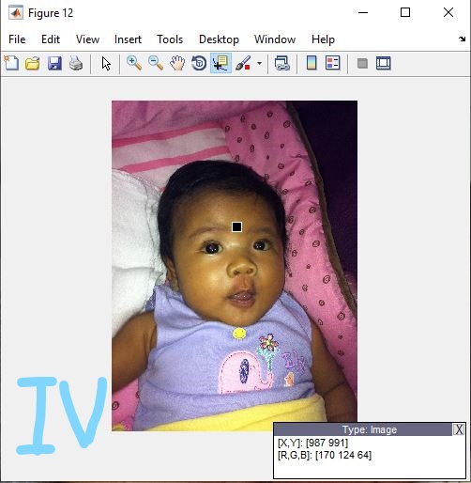

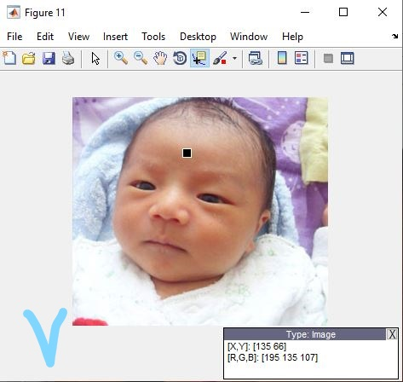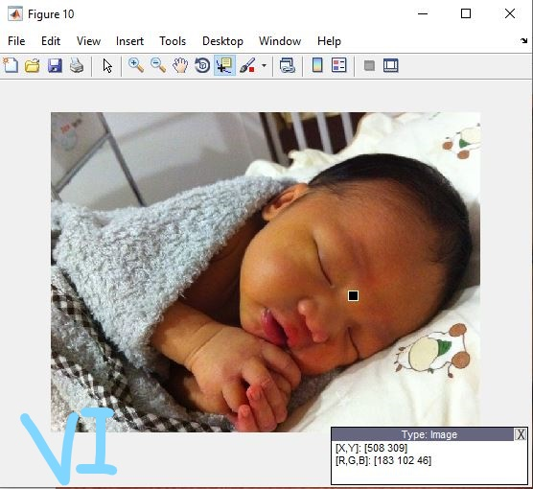

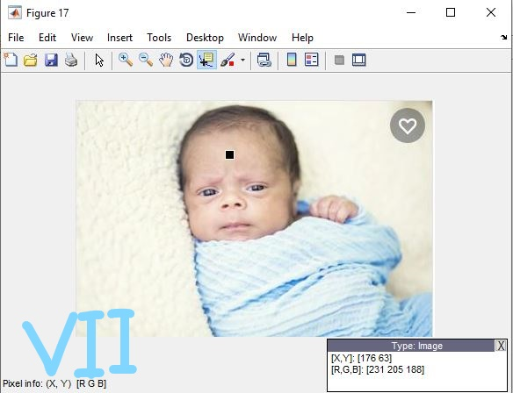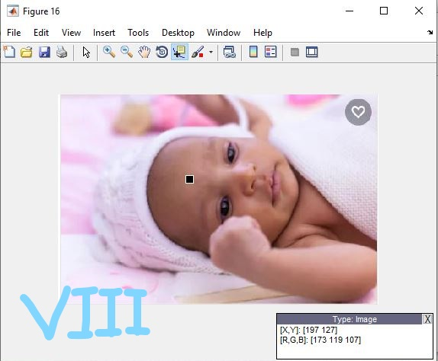

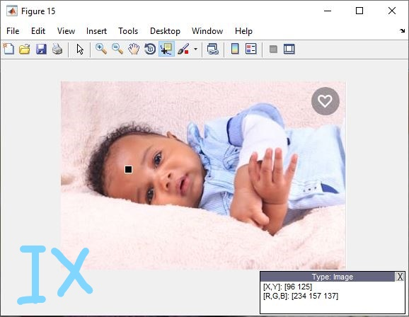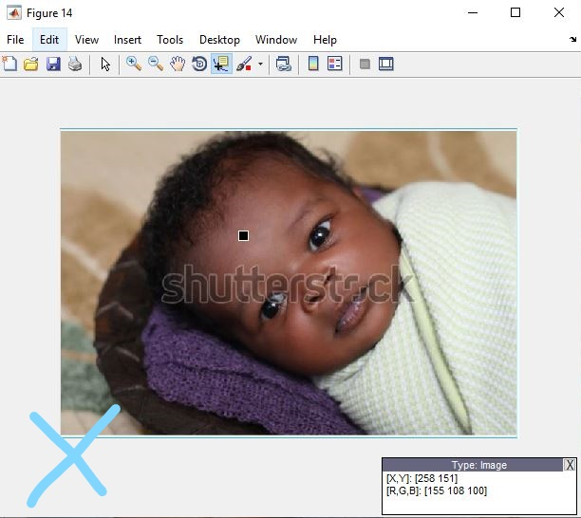

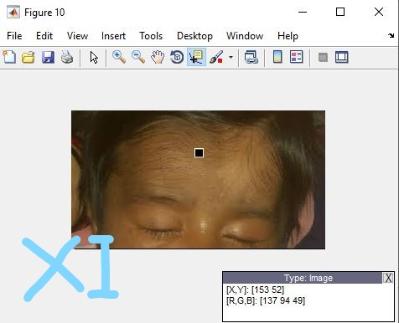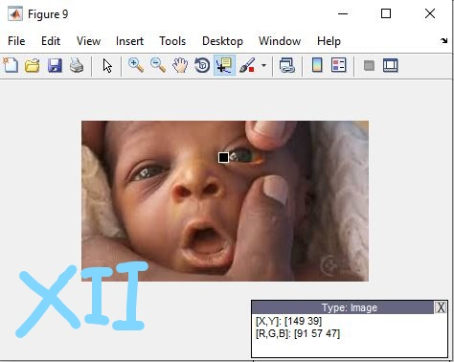

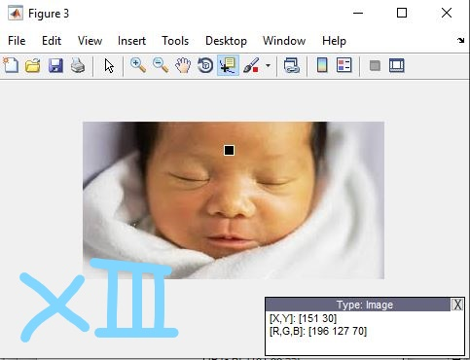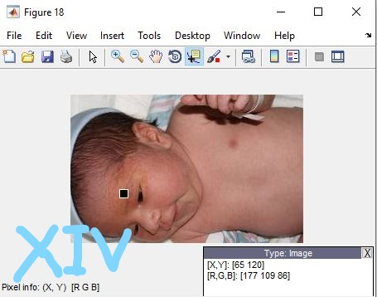

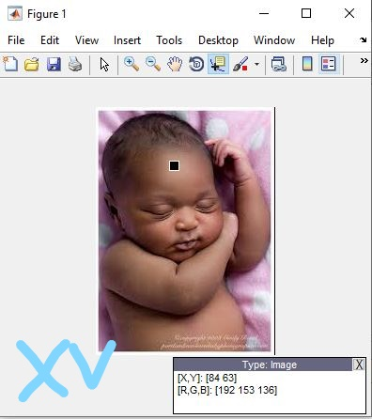

#### 3.4.4.1 TABLE SHOWING THE SUMMARY OF THE VIRTUAL DATA ANALYSIS

|  |  |  |  |  |
| --- | --- | --- | --- | --- |
| NEONATE | RGB VALUES | NORMALIZED BLUE % | ASSIGNED BILIRUBIN | STATE OF JAUNDICE |
| I | [162,87,29] | 10.24 | 17.99 | Severe |
| II | [224,181,147] | 26.63 | 5.23 | Mild |
| III | [194,126,79] | 19.79 | 10.55 | Severe |
| IV | [170,124,64] | 17.87 | 12.04 | Severe |
| V | [195,135,107] | 24.48 | 6.90 | Mild |
| VI | [183,102,46] | 13.89 | 15.15 | Severe |
| VII | [231,205,188] | 30.12 | 2.50 | Normal |
| VIII | [173,119,107] | 26.81 | 5.09 | Mild |
| IX | [234,157,137] | 25.94 | 5.76 | Mild |
| X | [155,108,100] | 27.54 | 4.51 | Mild |
| XI | [137,94,49] | 17.5 | 12.33 | Severe |
| XII | [91,57,47] | 24.10 | 7.19 | Mild |
| XIII | [196,127,70] | 17.81 | 12.09 | Severe |
| XIV | [107,109,86] | 28.47 | 3.79 | Normal |
| XV | [192,153,162] | 31.95 | 1.08 | Normal |

#### 3.4.4.2 MATLAB SCATTER PLOT WITH LINE OF BEST FIT

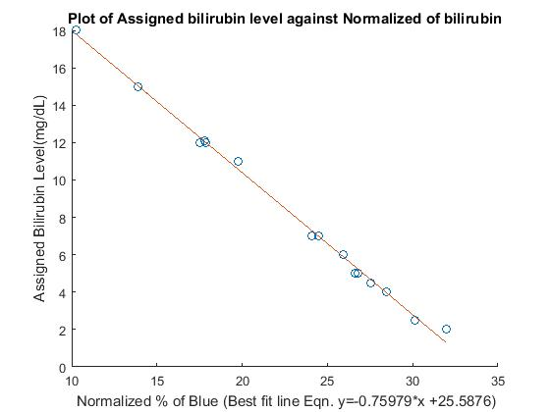

From the graph above, the best fit equation showing the correlation between assigned bilirubin level and normalized % of blue is established as:

|  |
| --- |
| **Y= -0.75979*X + 25.5876** |

# CHAPTER 4

# RESULTS AND DISCUSSION

## 4.1 Chapter Summary

This chapter entails the results of testing our device with neonatal skin shades of jaundiced and non-jaundiced images printed on paper. The results show the RGB readings of the printed image, the corresponding calculated normalized blue percentage, and finally it displays the jaundice state from the ascertained bilirubin level concentration.

## 4.2 Preliminary Testing of Device

The correlation equation established from the virtual data analysis was uploaded to the microcontroller for final device configuration. In the preliminary testing of the device functionality, the device was tested using an ordinary printed image having different color shades. The observed results is shown below.

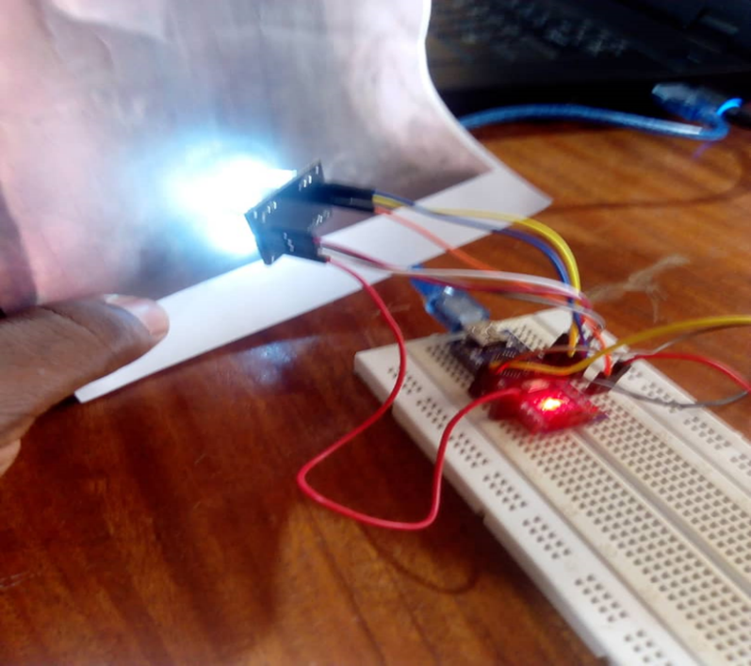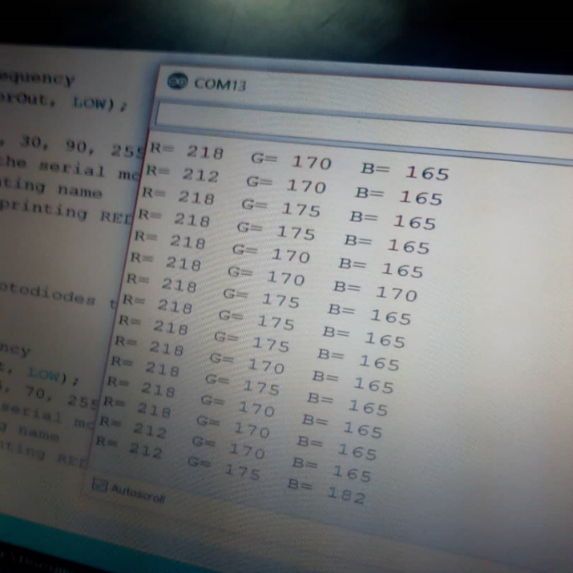

The RGB reading showed by the serial monitor is an indication that our device is well configured and as such is functioning as expected.

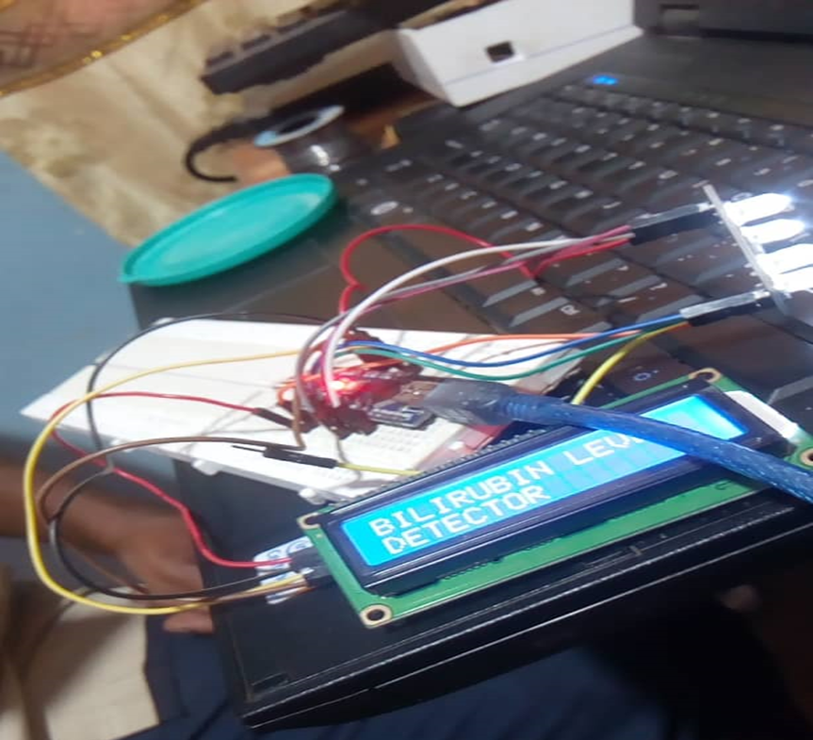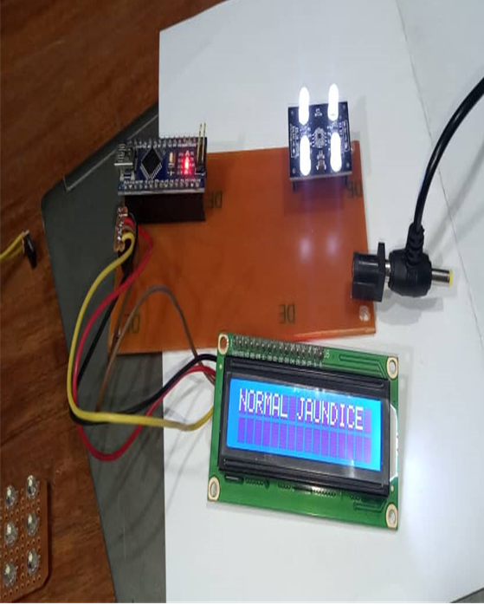

# 4.3 Final Testing of Device

The device is used to determine the bilirubin level of both jaundiced and non-jaundiced skin shades of neonates printed on paper. The results of the experimentation is captured below.

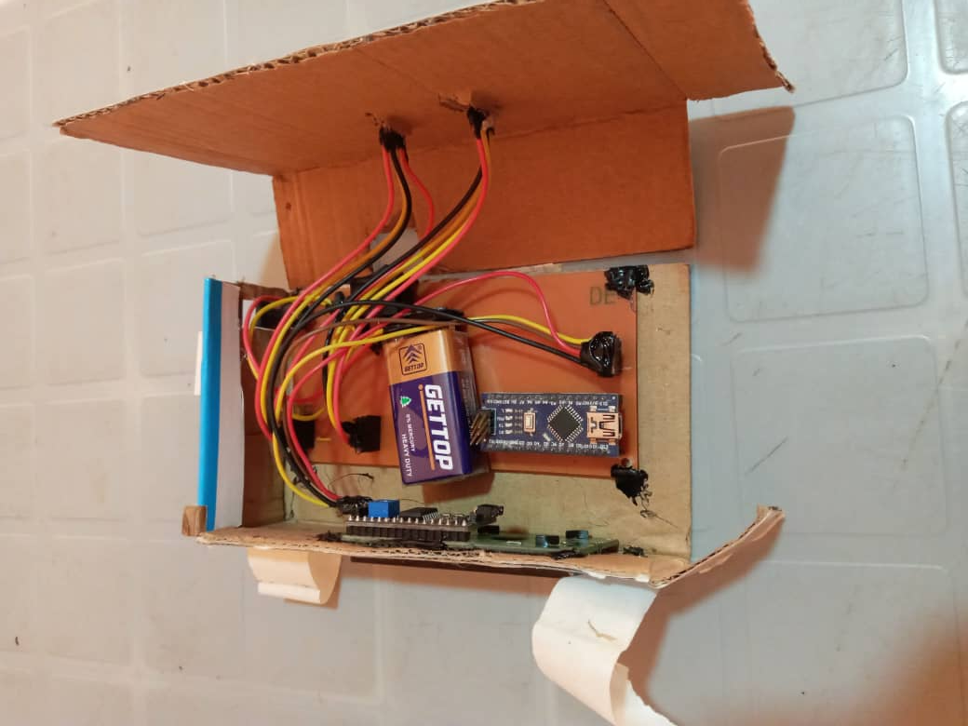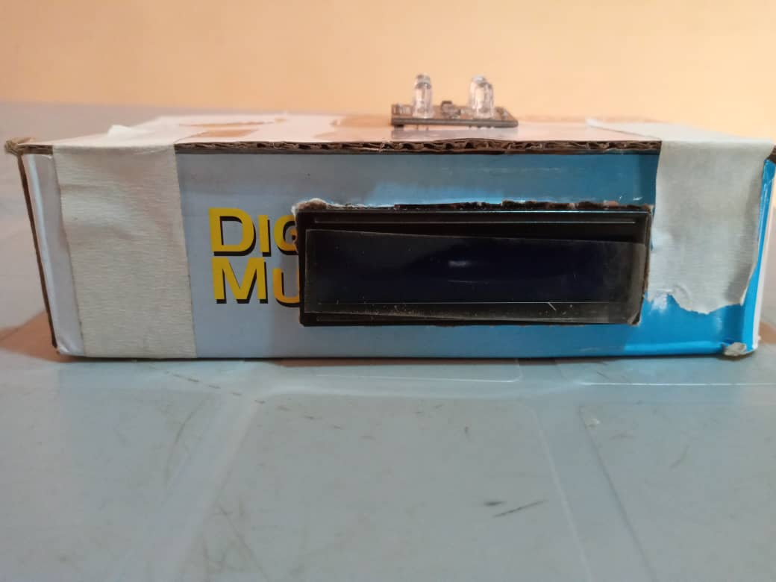

Three images were used for the testing;

### 4.3.1 Test 1

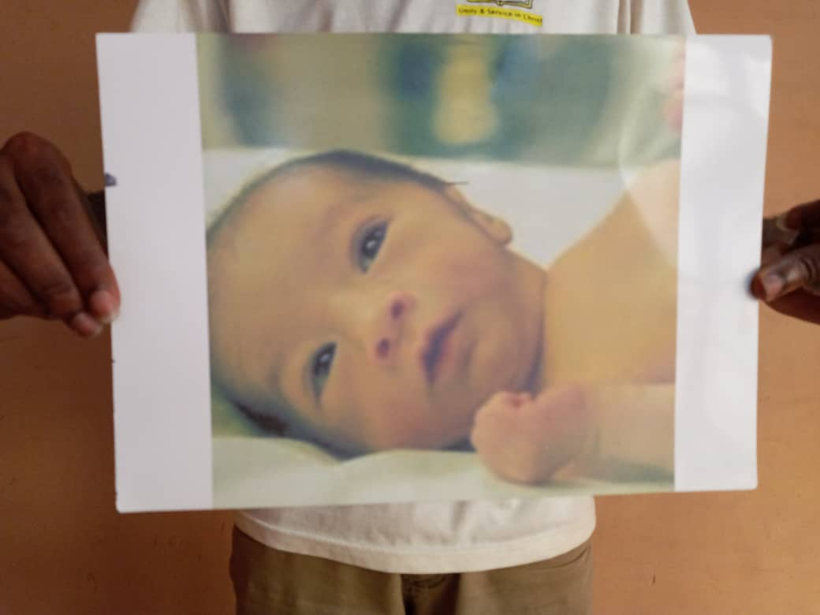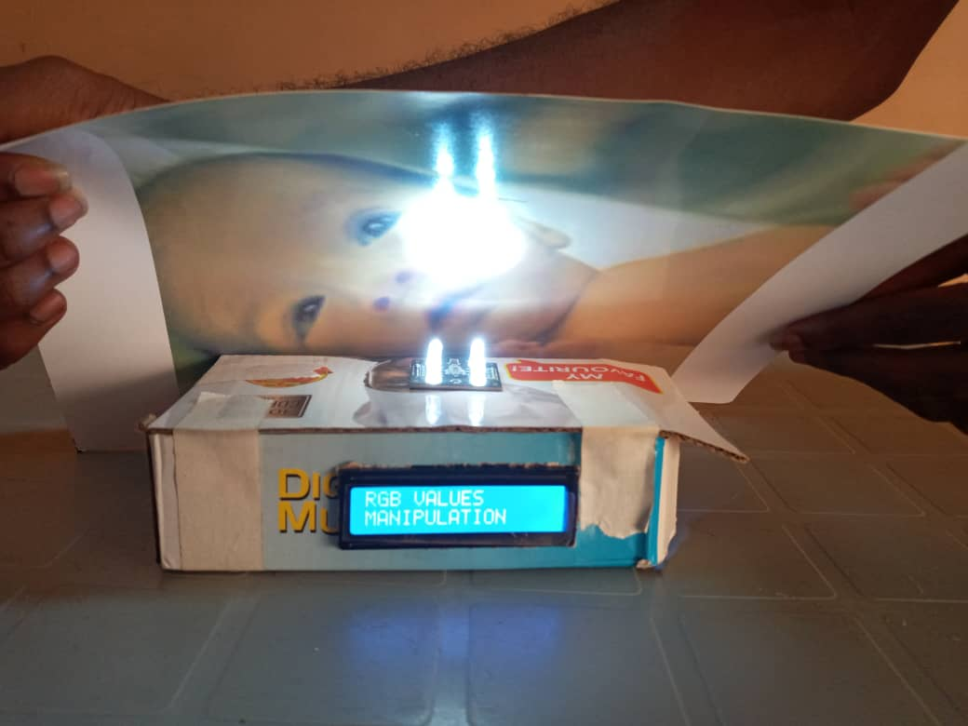

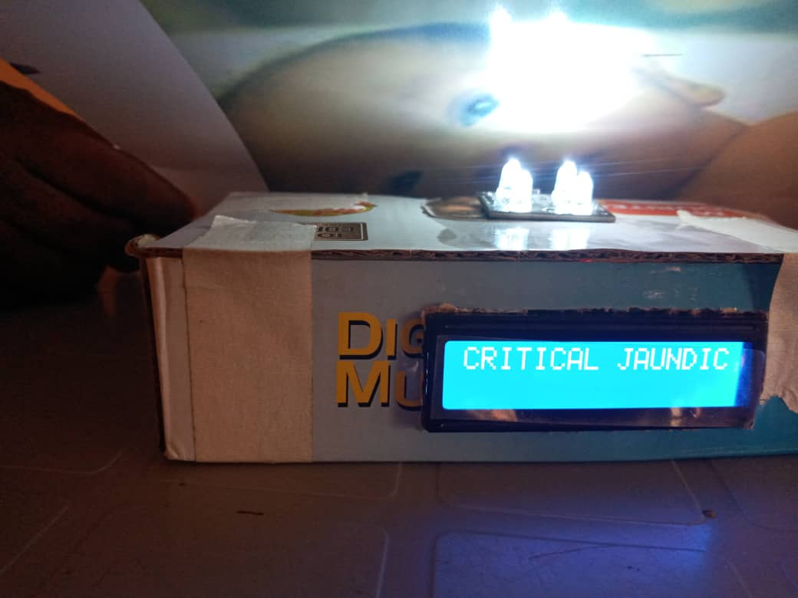

### 4.3.2 Test 2

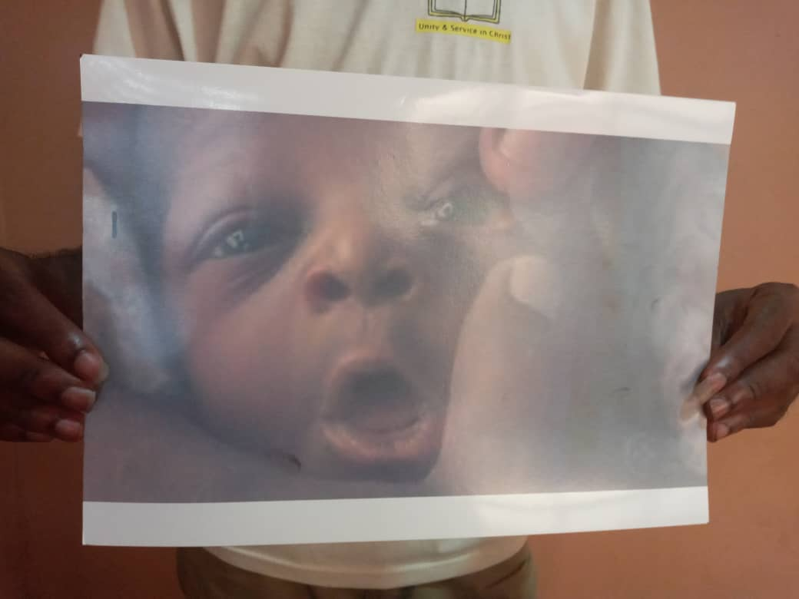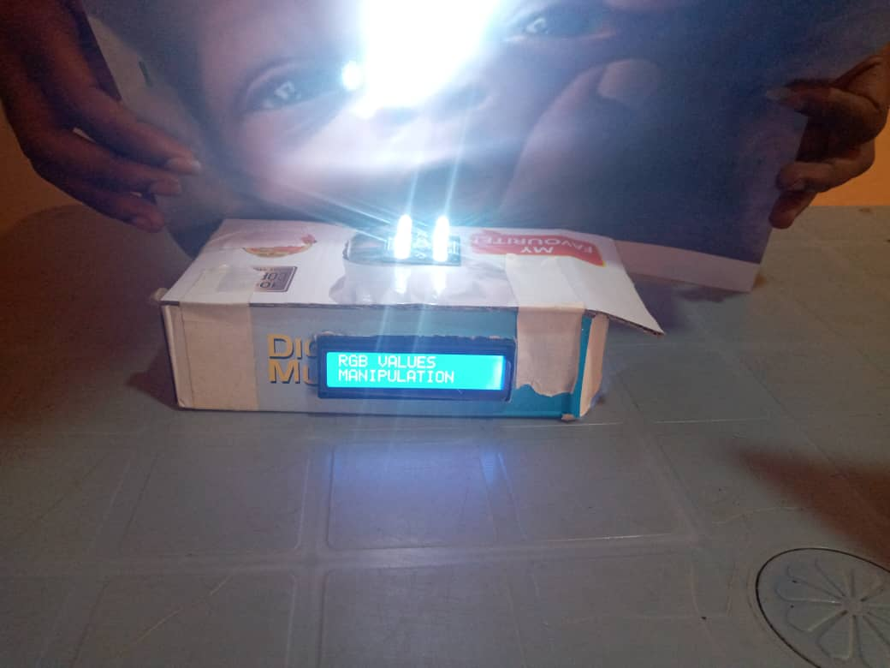

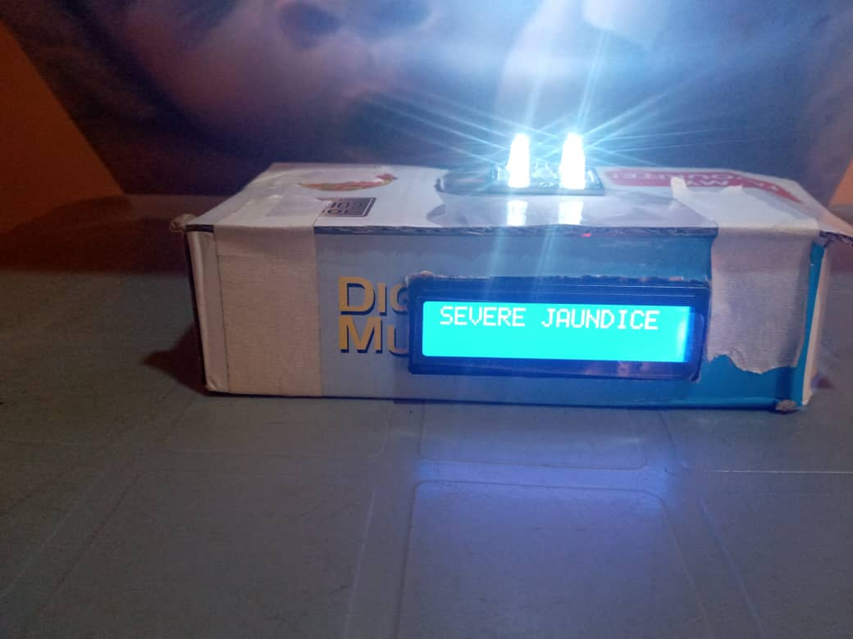

### 4.3.3 Test 3

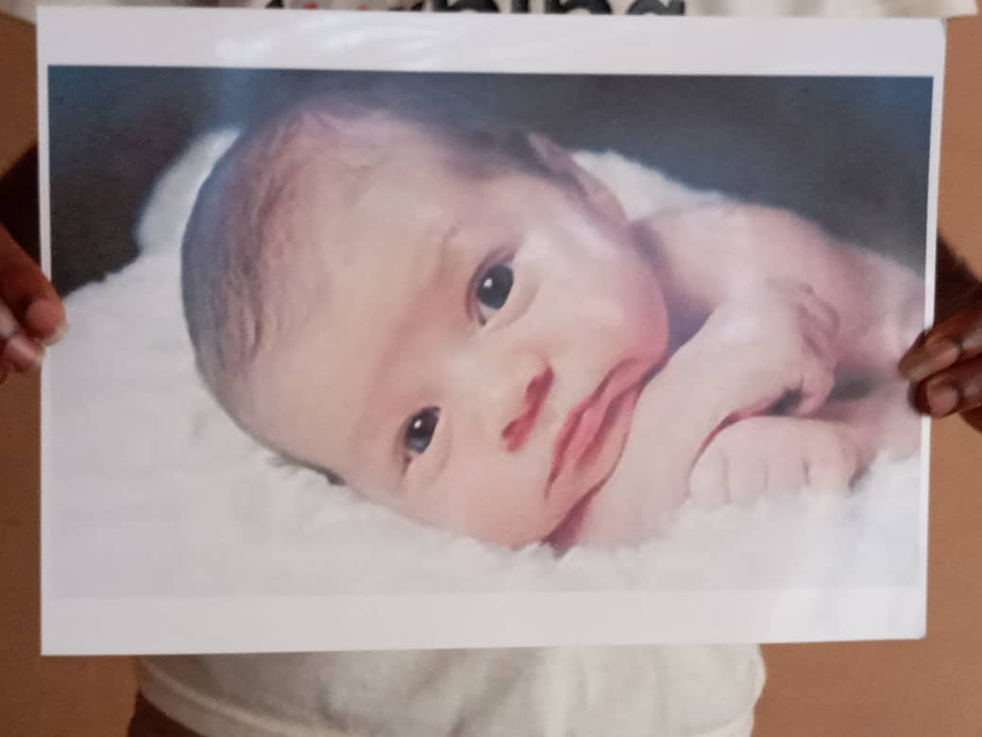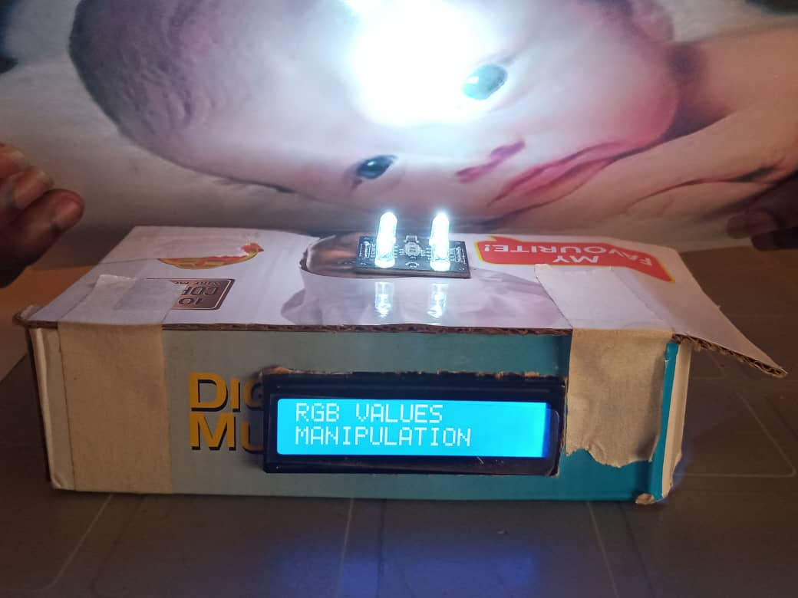

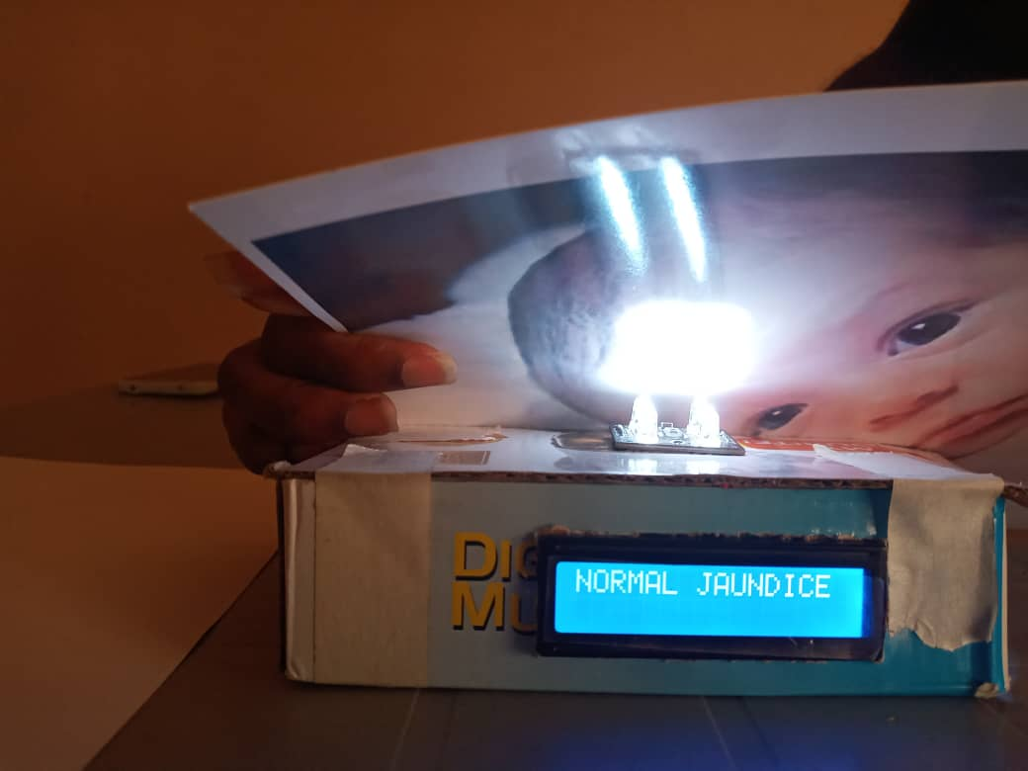

## 4.4 DISCUSSIONS

It could be emphasized from the results from the testing of the device that, the device is working effectively as programmed and expected. Moreover, it was observed that the effect of ambient light and also distance of separation between the sensor and the printed image has great influence of the readings produced by the device. In attempt of improving the sensitivity and efficiency of the sensor of our device, the scenarios below were considered and deployed to maintain the sensor – object harmony.

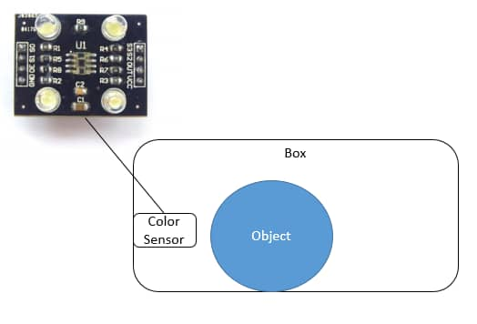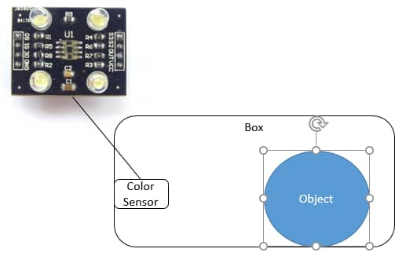

The illustrations above depict the two distance scenarios used to explain the sensor-object distance effect on the sensitivity of the sensor. Figure A shows a close distance of separation while Figure B shows a far distance relation between the sensor and the object. It is worthy to note from our previous testing that, a close distance relation as shown by Figure A helps improves the sensor’s focus on the printed image; and hence improves the sensitivity of the sensor.

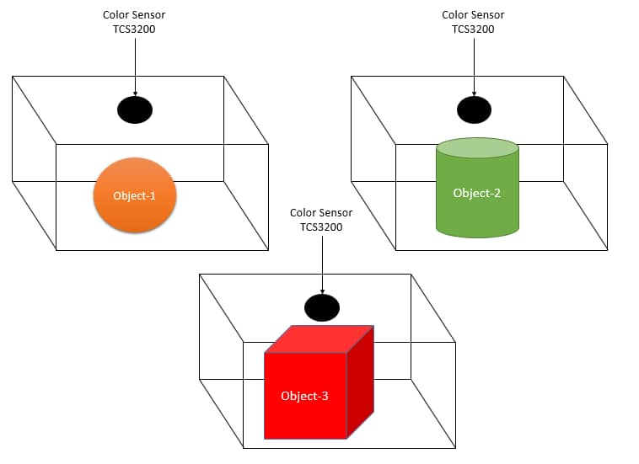

The above illustration also depicts how the effect of ambient light on the sensor’s sensitivity was minimized. In the illustration, it is seen that the object is placed in an enclosed box so as to be focused upon by the light of the sensor only. Here, ambient light effect on device reading is minimally abated thus there is much assurance of less error in the results shown by the device.

### 4.4.1 INCORPORATION OF THE ABOVE MEASURES WITH OUR DEVICE

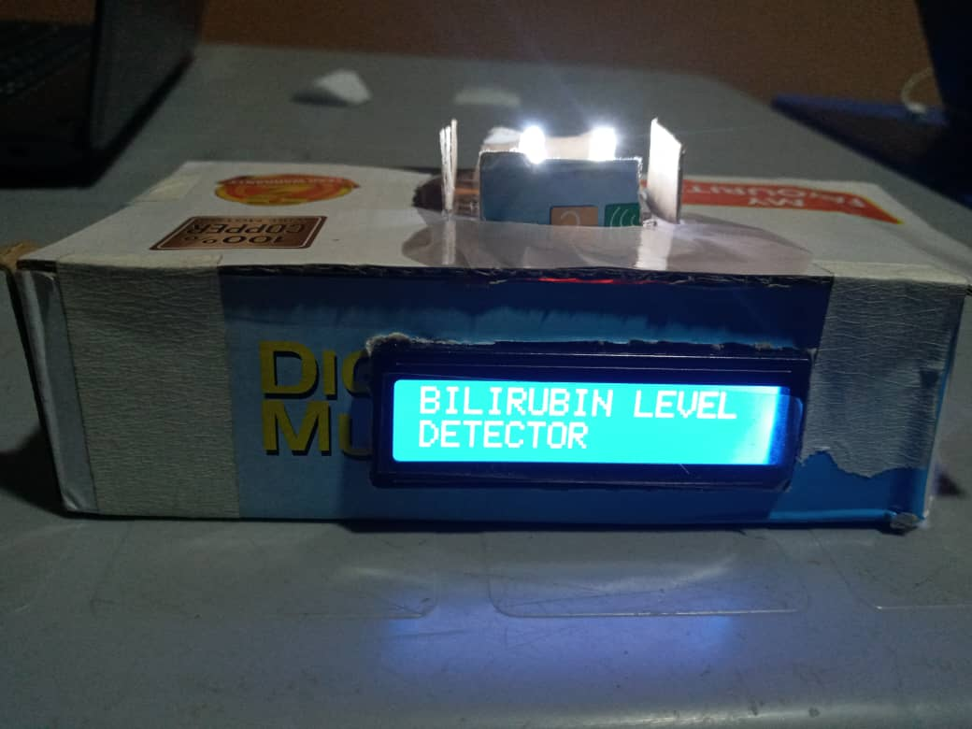

# CHAPTER 5

# CONCLUSION AND RECOMMENDATION

## 5.1 Chapter Summary

This chapter comprises the outcome of our expectations for this project. It also highlights the limitations associated with this work; and more importantly this chapter also focuses on some recommendations necessary for the improvement of this project.

## 5.2 Conclusion

We were able to enhance jaundice diagnostic time by using image processing technique. We were also able to estimate the amount of blue component in neonatal skin shades after each section of phototherapy. The estimated blue component level is necessary in giving idea of the yellowish discoloration level of the neonate’s skin. Finally, we were able to determine the factors that have much influence on the accuracy of the results and readings given by the device. These factors include the effect of ambient light, and the maintained distance of separation between the sensor and the printed image. Ambient light influences the sensor’s sensitivity in reading the RGB values. The distance of separation between the sensor and the printed image also influences the reading.

## 5.3 Limitations

The main challenge of this project is the unavailability of real-life data from the hospital as a result of the restrictions and directives issued during the covid-19 pandemic season. In place of the actual real-life data for our project, we used online image samples of some selected neonates as the subjects for this work. This resulted in basing part of our data analysis on wise assumptions by the help of MATLAB image processing tool.

## 5.4 Recommendations

From the main limitation pointed above, it is therefore recommended to use real life data so as to minimally abate all forms of errors that may arise due to any false assumption made. Other recommendations and cautions made includes:

* Ensure a device friendly ambient environment when taking readings since ambient light can influence device reading.
* Maintain an effective short distance of separation between the sensor and the printed image to ensure an effective focus by the sensor.
* When taking readings with the device, the focus of the sensor must be targeted at the face of the neonate and no other irrelevant parts of the printed picture.

# REFERENCES

[1] Vreman H. J., Wong R. J. and Stevenson D. K. 2004. Phototherapy: Current Methods and Future Directions. Seminars in Perinatology. Vol.28, No. 5, pp. 326-333,

[2] S. Mishra, R. Agarwal, A. K. Deorari & V. K. Paul, ‘’Jaundice in the newborns,’’ Indian J. Pediatr.,75, 2 (2008) 157 – 163.

[3] National Collaborating Centre for Women’s and Children’s Health and Clinical Excellence. *Neonatal Jaundice Clinical Guideline.* London, 2010.

[4] Fahmi Akmal Dzulkifli1, Mohd Yusoff Mashor and Karniza Khalid, Methods for Determining Bilirubin Level in Neonatal Jaundice Screening and Monitoring: A Literature Review, Journal of Engineering Research and Education, Volume 10, 2018 [1-10]

[5] Ajay Kumar Chowdhary, Sudipta Dutta, Rabindranath Ghosh, Neonatal Jaundice Detection using Color Detection Method, International Advanced Research Journal in Science, Engineering and Technology ISO 3297:2007 Certified Vol. 4, Issue 7, July 2017

[6] L.L.C, "Collarborative Laboratory Services," 2011-2012. [Online]. Available: http://www.cdc.gov. [Accessed 21 November 2019].

[7]electronicsforu.com, 2019. *electronics foru.* [Online]   
Available at: http://electronicsforu.com

[8]Pololu Corporation, 2001-2019. *Pololu Corporation.* [Online]   
Available at: http://pololu.com  
[Accessed 31 December 2019].

[9]Robotshop Inc, 2019. *Robotshop Inc.* [Online]   
Available at: http://www.robotshop.com  
[Accessed 31 December 2019].

[10]Texas Advanced Optoelectronic Solutions, 2004. *TAOS inc.* [Online]   
Available at: http://taosinc.com  
[Accessed 31 December 2019].

[11] WebMD LLC, "Neonatal Jaundice," Medspace, 27 December 2017. [Online]. Available: http://emedicine.medspace.com/article/974786-overview#a4. [Accessed 24 November 2019]

[12] Baby gooroo, "Causes and types of jaundice explained," Women Owned, 2018. [Online]. Available: http://babygooroo.com/articles/causes-types-of-jaundice-explained. [Accessed 23 November 2019].

[13] Mansoor, M.N, Yaacob, S., Hariharan, M.,Basah, S.N., Ahmed Jamil, S.H.F.S. , Mohd Khidir, M.L., Rejab, M.N., Ku Ibrahim, K.M.Y , Ahmad Jamil, A.H.F.S., Saad, S.A, 2012,Jaundice in newborns Monitoring using Color Detection Method *,*International Workshop on Information and Electronic Engineering (IWIEE) ,pg. 1631-1635

[14] Practice update,” BiliCam, a Smartphone App, Screens Newborns for Jaundice”, ELSEVIER,2019[Online]. Available : <https://www.practiceupdate.com/content/bilicam-a-smartphone-app-screens-newborns-for-jaundice/57903> . [Accessed 26 July 2020]

[15] Chimhini, G.L.T., Chimhuya, S. & Chikwasha, V. Evaluation of transcutaneous bilirubinometer (DRAEGER JM 103) use in Zimbabwean newborn babies. *matern health, neonatol and perinatol* **4,**1 (2018). <https://doi.org/10.1186/s40748-017-0070-0>

[16] Puriapp Inc, 2019. ,Urinalysis test strips,*Puriapp Inc.* [Online]   
Available at: <https://puriapp.com/urinalysis-test-strips/>  
[Accessed 27 June 2020].

# APENDICES

## FLOW CHART OF MICRO-CONTROLLER CODE

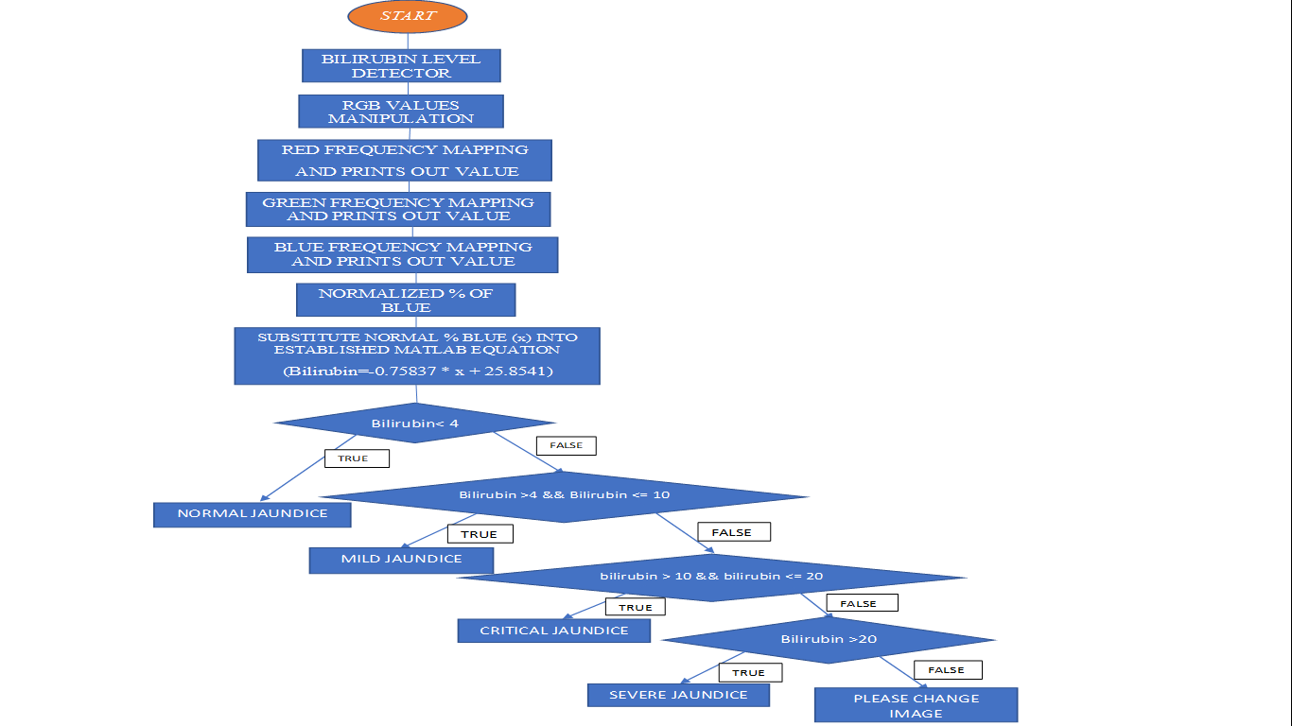

## MATLAB CODE FOR IMPLEMENTING IMAGE PROCESSING ON THE NEONATES IMAGES

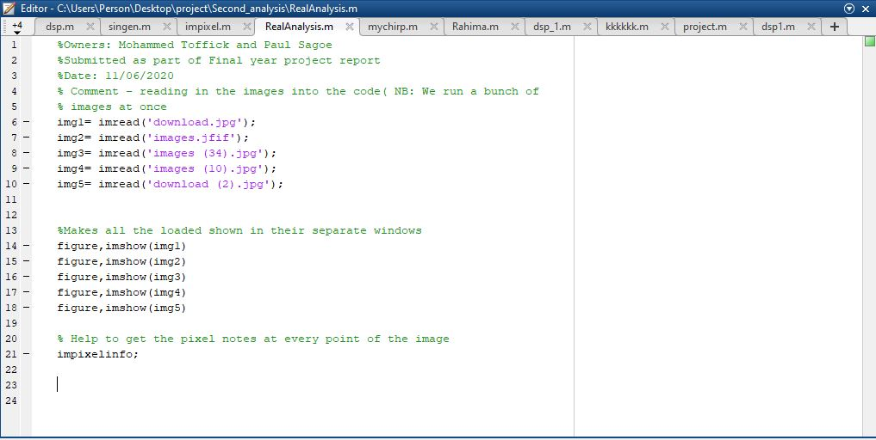

## TRAINING DATA RELATING NORMALIZED % OF BLUE AND BILIRUBIN LEVEL

|  |  |  |  |
| --- | --- | --- | --- |
| Sample | Shade of Skin | Assigned Bilirubin level (mg/dL) | Normalized % of Blue |
| A |  | 1.5 | 31.30 |
| B |  | 2.5 | 27.21 |
| C |  | 8.5 | 23.30 |
| D |  | 16 | 17.42 |
| E |  | 21 | 4.42 |
| F |  | 23 | 3.57 |

## TABLE SHOWING THE SUMMARY OF THE VIRTUAL DATA ANALYSIS

|  |  |  |  |  |
| --- | --- | --- | --- | --- |
| NEONATE | RGB VALUES | NORMALIZED BLUE % | ASSIGNED Bilirubin Level | STATE OF JAUNDICE |
| I | [162,87,29] | 10.24 | 17.99 | Severe |
| II | [224,181,147] | 26.63 | 5.23 | Mild |
| III | [194,126,79] | 19.79 | 10.55 | Severe |
| IV | [170,124,64] | 17.87 | 12.04 | Severe |
| V | [195,135,107] | 24.48 | 6.90 | Mild |
| VI | [183,102,46] | 13.89 | 15.15 | Severe |
| VII | [231,205,188] | 30.12 | 2.50 | Normal |
| VIII | [173,119,107] | 26.81 | 5.09 | Mild |
| IX | [234,157,137] | 25.94 | 5.76 | Mild |
| X | [155,108,100] | 27.54 | 4.51 | Mild |
| XI | [137,94,49] | 17.5 | 12.33 | Severe |
| XII | [91,57,47] | 24.10 | 7.19 | Mild |
| XIII | [196,127,70] | 17.81 | 12.09 | Severe |
| XIV | [107,109,86] | 28.47 | 3.79 | Normal |
| XV | [192,153,162] | 31.95 | 1.08 | Normal |

## ARDUINO NANO CODE

#include <Wire.h>

#include <LCD.h>

#include <LiquidCrystal_I2C.h>

#include <Wire.h>

#define S0 4

#define S1 5

#define S2 6

#define S3 7

#define sensorOut 8

LiquidCrystal_I2C lcd(0x27, 2, 1, 0, 4, 5, 6, 7, 3,POSITIVE); //3f//27

int frequency = 0;

int R_frequency = 0;

int G_frequency = 0;

float B_frequency = 0;

float percentage = 0.0;

int total = 0;

float division = 0.0;

float bilirubin = 0.0;

void setup() {

pinMode(S0, OUTPUT);

pinMode(S1, OUTPUT);

pinMode(S2, OUTPUT);

pinMode(S3, OUTPUT);

pinMode(sensorOut, INPUT);

lcd.begin(16,2);

lcd.setBacklight(HIGH);

lcd.clear();

lcd.home();

lcd.print("BILIRUBIN LEVEL");

lcd.setCursor(0,1);

lcd.print("DETECTOR");

delay(2000);

lcd.clear();

// Setting frequency-scaling to 20%

digitalWrite(S0,HIGH);

digitalWrite(S1,LOW);

Serial.begin(9600);

}

void loop() {

// Setting red filtered photodiodes to be read

digitalWrite(S2,LOW);

digitalWrite(S3,LOW);

// Reading the output frequency

frequency = pulseIn(sensorOut, LOW);

//frequency2 = pulseIn(sensorOut, LOW);

//frequency3 = pulseIn(sensorOut, LOW);

//frequency2 = pulseIn(sensorOut, LOW);

//frequency3 = pulseIn(sensorOut, LOW);

lcd.setCursor(0,0);

lcd.print("RGB VALUES");

lcd.setCursor(0,1);

lcd.print("MANIPULATION");

delay(2000);

lcd.clear();

//lcd.setCursor(0,0);

//lcd.print(frequency1);

R_frequency = map(frequency, 25, 72, 255, 0);

lcd.setCursor(0,0);

lcd.print("R= ");//printing name

lcd.print(R_frequency);//printing RED color frequency

lcd.print(" ");

delay(1000);

// Setting Green filtered photodiodes to be read

digitalWrite(S2,HIGH);

digitalWrite(S3,HIGH);

// Reading the output frequency

frequency = pulseIn(sensorOut, LOW);

G_frequency= map(frequency, 30, 90, 255, 0);

// Printing the value on the serial monitor

lcd.setCursor(0,1);

lcd.print("G= ");//printing name

lcd.print(G_frequency);//printing RED color frequency

lcd.print(" ");

delay(1000);

// Setting Blue filtered photodiodes to be read

digitalWrite(S2,LOW);

digitalWrite(S3,HIGH);

// Reading the output frequency

frequency = pulseIn(sensorOut, LOW);

B_frequency= map(frequency, 25, 70, 255, 0);

// Printing the value on the serial monitor

//lcd.setCursor(0,1);

lcd.print("B= ");//printing name

lcd.print(B_frequency);//printing RED color frequency

lcd.println(" ");

delay(1000);

lcd.clear();

total = R_frequency + G_frequency + B_frequency;

division = B_frequency / total;

percentage = division * 100;

//Serial.println(total);

//Serial.print(division);

lcd.setCursor(0,0);

lcd.print("NORMAL BLUE %=");

lcd.setCursor(0,1);

lcd.print(percentage);

delay(2000);

lcd.clear();

lcd.setCursor(0,0);

bilirubin = -0.75979 * percentage + 25.5876;

Serial.println(bilirubin);

if (bilirubin < 4){

lcd.print("NORMAL JAUNDICE");

}

else if(bilirubin > 4 && bilirubin <= 10){

lcd.print("MILD JAUNDICE");

}

else if(bilirubin > 10 && bilirubin <= 20){

lcd.print("SEVERE JAUNDICE");

}

else if(bilirubin > 20){

lcd.print("CRITICAL JAUNDICE");

}

delay(3000);

lcd.clear();

}